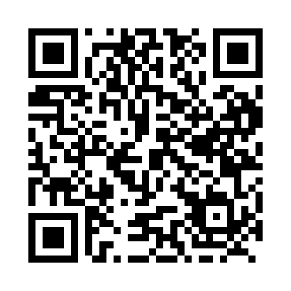
Prayer times for Killiniq, Quebec, Canada
Mon 1 Jul 2024 - Wed 31 Jul 2024
High Latitude Method: Angle Based Rule
Prayer Calculation Method: Islamic Society of North America
Asar Calculation Method: Hanafi

Date | Day | Fajr | Sunrise | Dhuhr | Asr | Maghrib | Isha
1 | Mon | 1:40 | 2:58 | 12:23 | 6:23 | 9:49 | 11:06
2 | Tue | 1:41 | 2:59 | 12:24 | 6:23 | 9:48 | 11:06
3 | Wed | 1:42 | 3:00 | 12:24 | 6:23 | 9:47 | 11:05
4 | Thu | 1:43 | 3:01 | 12:24 | 6:23 | 9:46 | 11:05
5 | Fri | 1:43 | 3:03 | 12:24 | 6:22 | 9:45 | 11:04
6 | Sat | 1:44 | 3:04 | 12:24 | 6:22 | 9:43 | 11:04
7 | Sun | 1:45 | 3:06 | 12:24 | 6:21 | 9:42 | 11:03
8 | Mon | 1:46 | 3:08 | 12:25 | 6:21 | 9:41 | 11:02
9 | Tue | 1:47 | 3:09 | 12:25 | 6:20 | 9:39 | 11:02
10 | Wed | 1:48 | 3:11 | 12:25 | 6:20 | 9:38 | 11:01
11 | Thu | 1:49 | 3:13 | 12:25 | 6:19 | 9:36 | 11:00
12 | Fri | 1:50 | 3:15 | 12:25 | 6:18 | 9:35 | 11:00
13 | Sat | 1:51 | 3:16 | 12:25 | 6:18 | 9:33 | 10:59
14 | Sun | 1:52 | 3:18 | 12:25 | 6:17 | 9:31 | 10:58
15 | Mon | 1:53 | 3:20 | 12:25 | 6:16 | 9:29 | 10:57
16 | Tue | 1:54 | 3:22 | 12:25 | 6:15 | 9:28 | 10:56
17 | Wed | 1:55 | 3:25 | 12:26 | 6:15 | 9:26 | 10:55
18 | Thu | 1:56 | 3:27 | 12:26 | 6:14 | 9:24 | 10:54
19 | Fri | 1:57 | 3:29 | 12:26 | 6:13 | 9:22 | 10:53
20 | Sat | 1:58 | 3:31 | 12:26 | 6:12 | 9:19 | 10:52
21 | Sun | 1:59 | 3:33 | 12:26 | 6:11 | 9:17 | 10:51
22 | Mon | 2:00 | 3:35 | 12:26 | 6:10 | 9:15 | 10:50
23 | Tue | 2:01 | 3:38 | 12:26 | 6:09 | 9:13 | 10:49
24 | Wed | 2:03 | 3:40 | 12:26 | 6:07 | 9:11 | 10:48
25 | Thu | 2:04 | 3:42 | 12:26 | 6:06 | 9:08 | 10:47
26 | Fri | 2:05 | 3:45 | 12:26 | 6:05 | 9:06 | 10:46
27 | Sat | 2:06 | 3:47 | 12:26 | 6:04 | 9:04 | 10:44
28 | Sun | 2:07 | 3:49 | 12:26 | 6:02 | 9:01 | 10:43
29 | Mon | 2:08 | 3:52 | 12:26 | 6:01 | 8:59 | 10:42
30 | Tue | 2:10 | 3:54 | 12:26 | 6:00 | 8:56 | 10:41
31 | Wed | 2:11 | 3:56 | 12:26 | 5:58 | 8:54 | 10:39
Prayer times provided by https://www.salahtimes.com

