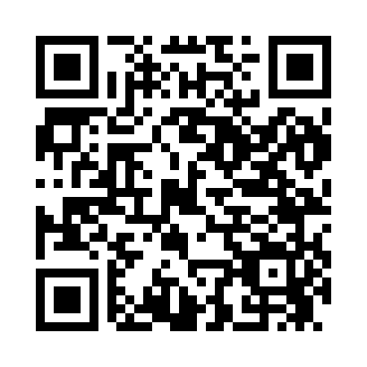
Prayer times for Bellcrest Park, New Jersey, USA
Wed 1 May 2024 - Fri 31 May 2024
High Latitude Method: Angle Based Rule
Prayer Calculation Method: Islamic Society of North America
Asar Calculation Method: Shafi

Date | Day | Fajr | Sunrise | Dhuhr | Asr | Maghrib | Isha
1 | Wed | 4:32 | 5:56 | 12:54 | 4:44 | 7:52 | 9:16
2 | Thu | 4:30 | 5:55 | 12:53 | 4:44 | 7:53 | 9:17
3 | Fri | 4:29 | 5:54 | 12:53 | 4:45 | 7:54 | 9:19
4 | Sat | 4:27 | 5:52 | 12:53 | 4:45 | 7:55 | 9:20
5 | Sun | 4:26 | 5:51 | 12:53 | 4:45 | 7:56 | 9:21
6 | Mon | 4:24 | 5:50 | 12:53 | 4:45 | 7:57 | 9:23
7 | Tue | 4:23 | 5:49 | 12:53 | 4:46 | 7:58 | 9:24
8 | Wed | 4:21 | 5:48 | 12:53 | 4:46 | 7:59 | 9:25
9 | Thu | 4:20 | 5:47 | 12:53 | 4:46 | 8:00 | 9:27
10 | Fri | 4:19 | 5:46 | 12:53 | 4:46 | 8:01 | 9:28
11 | Sat | 4:17 | 5:45 | 12:53 | 4:47 | 8:02 | 9:29
12 | Sun | 4:16 | 5:44 | 12:53 | 4:47 | 8:03 | 9:31
13 | Mon | 4:14 | 5:43 | 12:53 | 4:47 | 8:04 | 9:32
14 | Tue | 4:13 | 5:42 | 12:53 | 4:47 | 8:05 | 9:33
15 | Wed | 4:12 | 5:41 | 12:53 | 4:48 | 8:05 | 9:35
16 | Thu | 4:11 | 5:40 | 12:53 | 4:48 | 8:06 | 9:36
17 | Fri | 4:09 | 5:39 | 12:53 | 4:48 | 8:07 | 9:37
18 | Sat | 4:08 | 5:38 | 12:53 | 4:49 | 8:08 | 9:39
19 | Sun | 4:07 | 5:37 | 12:53 | 4:49 | 8:09 | 9:40
20 | Mon | 4:06 | 5:37 | 12:53 | 4:49 | 8:10 | 9:41
21 | Tue | 4:05 | 5:36 | 12:53 | 4:49 | 8:11 | 9:42
22 | Wed | 4:04 | 5:35 | 12:53 | 4:50 | 8:12 | 9:44
23 | Thu | 4:03 | 5:34 | 12:53 | 4:50 | 8:13 | 9:45
24 | Fri | 4:02 | 5:34 | 12:53 | 4:50 | 8:13 | 9:46
25 | Sat | 4:01 | 5:33 | 12:54 | 4:50 | 8:14 | 9:47
26 | Sun | 4:00 | 5:33 | 12:54 | 4:51 | 8:15 | 9:48
27 | Mon | 3:59 | 5:32 | 12:54 | 4:51 | 8:16 | 9:49
28 | Tue | 3:58 | 5:31 | 12:54 | 4:51 | 8:17 | 9:50
29 | Wed | 3:57 | 5:31 | 12:54 | 4:51 | 8:17 | 9:52
30 | Thu | 3:56 | 5:31 | 12:54 | 4:52 | 8:18 | 9:53
31 | Fri | 3:56 | 5:30 | 12:54 | 4:52 | 8:19 | 9:54
Prayer times provided by https://www.salahtimes.com

