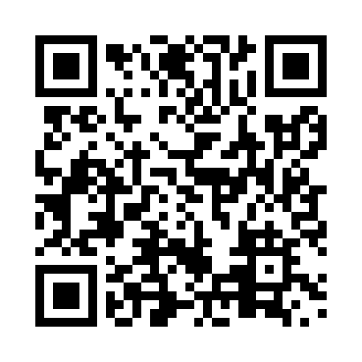
Prayer times for Sarita, British Columbia, Canada
Mon 1 Jul 2024 - Wed 31 Jul 2024
High Latitude Method: Angle Based Rule
Prayer Calculation Method: Islamic Society of North America
Asar Calculation Method: Hanafi

Date | Day | Fajr | Sunrise | Dhuhr | Asr | Maghrib | Isha
1 | Mon | 3:23 | 5:21 | 1:24 | 6:54 | 9:27 | 11:26
2 | Tue | 3:23 | 5:22 | 1:24 | 6:54 | 9:27 | 11:25
3 | Wed | 3:23 | 5:23 | 1:25 | 6:54 | 9:26 | 11:25
4 | Thu | 3:24 | 5:23 | 1:25 | 6:54 | 9:26 | 11:25
5 | Fri | 3:24 | 5:24 | 1:25 | 6:54 | 9:25 | 11:25
6 | Sat | 3:25 | 5:25 | 1:25 | 6:54 | 9:25 | 11:25
7 | Sun | 3:25 | 5:26 | 1:25 | 6:53 | 9:24 | 11:25
8 | Mon | 3:26 | 5:27 | 1:25 | 6:53 | 9:24 | 11:24
9 | Tue | 3:26 | 5:27 | 1:26 | 6:53 | 9:23 | 11:24
10 | Wed | 3:27 | 5:28 | 1:26 | 6:53 | 9:22 | 11:24
11 | Thu | 3:27 | 5:29 | 1:26 | 6:52 | 9:22 | 11:24
12 | Fri | 3:28 | 5:30 | 1:26 | 6:52 | 9:21 | 11:23
13 | Sat | 3:29 | 5:31 | 1:26 | 6:52 | 9:20 | 11:23
14 | Sun | 3:29 | 5:32 | 1:26 | 6:51 | 9:19 | 11:23
15 | Mon | 3:30 | 5:33 | 1:26 | 6:51 | 9:18 | 11:22
16 | Tue | 3:30 | 5:35 | 1:26 | 6:50 | 9:18 | 11:22
17 | Wed | 3:31 | 5:36 | 1:26 | 6:50 | 9:17 | 11:21
18 | Thu | 3:32 | 5:37 | 1:26 | 6:49 | 9:16 | 11:21
19 | Fri | 3:32 | 5:38 | 1:27 | 6:49 | 9:15 | 11:20
20 | Sat | 3:34 | 5:39 | 1:27 | 6:48 | 9:13 | 11:18
21 | Sun | 3:37 | 5:40 | 1:27 | 6:47 | 9:12 | 11:15
22 | Mon | 3:39 | 5:42 | 1:27 | 6:47 | 9:11 | 11:13
23 | Tue | 3:41 | 5:43 | 1:27 | 6:46 | 9:10 | 11:11
24 | Wed | 3:43 | 5:44 | 1:27 | 6:45 | 9:09 | 11:09
25 | Thu | 3:45 | 5:45 | 1:27 | 6:45 | 9:07 | 11:07
26 | Fri | 3:48 | 5:47 | 1:27 | 6:44 | 9:06 | 11:05
27 | Sat | 3:50 | 5:48 | 1:27 | 6:43 | 9:05 | 11:02
28 | Sun | 3:52 | 5:49 | 1:27 | 6:42 | 9:03 | 11:00
29 | Mon | 3:54 | 5:50 | 1:27 | 6:42 | 9:02 | 10:58
30 | Tue | 3:57 | 5:52 | 1:27 | 6:41 | 9:01 | 10:55
31 | Wed | 3:59 | 5:53 | 1:26 | 6:40 | 8:59 | 10:53
Prayer times provided by https://www.salahtimes.com

