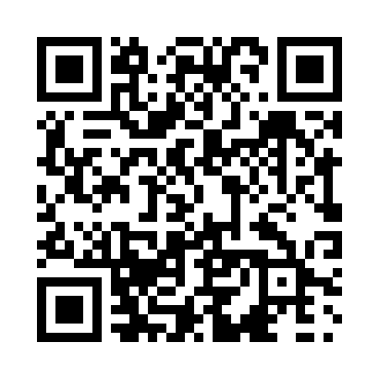
Prayer times for Armagh, Quebec, Canada
Wed 1 May 2024 - Fri 31 May 2024
High Latitude Method: Angle Based Rule
Prayer Calculation Method: Islamic Society of North America
Asar Calculation Method: Hanafi

Date | Day | Fajr | Sunrise | Dhuhr | Asr | Maghrib | Isha
1 | Wed | 3:47 | 5:26 | 12:39 | 5:42 | 7:53 | 9:32
2 | Thu | 3:45 | 5:25 | 12:39 | 5:42 | 7:54 | 9:34
3 | Fri | 3:43 | 5:23 | 12:39 | 5:43 | 7:56 | 9:36
4 | Sat | 3:41 | 5:22 | 12:39 | 5:44 | 7:57 | 9:38
5 | Sun | 3:39 | 5:20 | 12:39 | 5:45 | 7:58 | 9:40
6 | Mon | 3:37 | 5:19 | 12:39 | 5:46 | 8:00 | 9:42
7 | Tue | 3:35 | 5:18 | 12:39 | 5:46 | 8:01 | 9:44
8 | Wed | 3:33 | 5:16 | 12:39 | 5:47 | 8:02 | 9:46
9 | Thu | 3:31 | 5:15 | 12:39 | 5:48 | 8:03 | 9:48
10 | Fri | 3:28 | 5:13 | 12:39 | 5:49 | 8:05 | 9:50
11 | Sat | 3:26 | 5:12 | 12:39 | 5:49 | 8:06 | 9:52
12 | Sun | 3:24 | 5:11 | 12:39 | 5:50 | 8:07 | 9:54
13 | Mon | 3:23 | 5:10 | 12:39 | 5:51 | 8:08 | 9:56
14 | Tue | 3:21 | 5:08 | 12:39 | 5:52 | 8:10 | 9:58
15 | Wed | 3:19 | 5:07 | 12:39 | 5:52 | 8:11 | 10:00
16 | Thu | 3:17 | 5:06 | 12:39 | 5:53 | 8:12 | 10:02
17 | Fri | 3:15 | 5:05 | 12:39 | 5:54 | 8:13 | 10:04
18 | Sat | 3:13 | 5:04 | 12:39 | 5:55 | 8:15 | 10:06
19 | Sun | 3:11 | 5:03 | 12:39 | 5:55 | 8:16 | 10:07
20 | Mon | 3:10 | 5:02 | 12:39 | 5:56 | 8:17 | 10:09
21 | Tue | 3:08 | 5:01 | 12:39 | 5:57 | 8:18 | 10:11
22 | Wed | 3:06 | 5:00 | 12:39 | 5:57 | 8:19 | 10:13
23 | Thu | 3:04 | 4:59 | 12:39 | 5:58 | 8:20 | 10:15
24 | Fri | 3:03 | 4:58 | 12:39 | 5:59 | 8:21 | 10:17
25 | Sat | 3:01 | 4:57 | 12:39 | 5:59 | 8:22 | 10:18
26 | Sun | 3:00 | 4:56 | 12:39 | 6:00 | 8:23 | 10:20
27 | Mon | 2:58 | 4:55 | 12:40 | 6:00 | 8:24 | 10:22
28 | Tue | 2:57 | 4:54 | 12:40 | 6:01 | 8:25 | 10:23
29 | Wed | 2:55 | 4:54 | 12:40 | 6:02 | 8:26 | 10:25
30 | Thu | 2:54 | 4:53 | 12:40 | 6:02 | 8:27 | 10:27
31 | Fri | 2:53 | 4:52 | 12:40 | 6:03 | 8:28 | 10:28
Prayer times provided by https://www.salahtimes.com

