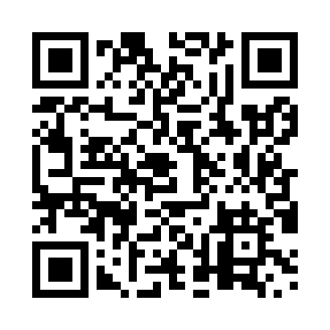
Prayer times for Norman Wells, Northwest Territories, Canada
Wed 1 May 2024 - Fri 31 May 2024
High Latitude Method: Angle Based Rule
Prayer Calculation Method: Islamic Society of North America
Asar Calculation Method: Hanafi

Date | Day | Fajr | Sunrise | Dhuhr | Asr | Maghrib | Isha
1 | Wed | 4:06 | 5:48 | 2:24 | 7:51 | 11:03 | 12:44
2 | Thu | 4:04 | 5:44 | 2:24 | 7:53 | 11:06 | 12:46
3 | Fri | 4:03 | 5:40 | 2:24 | 7:55 | 11:10 | 12:48
4 | Sat | 4:01 | 5:36 | 2:24 | 7:57 | 11:14 | 12:49
5 | Sun | 3:59 | 5:33 | 2:24 | 7:59 | 11:17 | 12:51
6 | Mon | 3:57 | 5:29 | 2:24 | 8:00 | 11:21 | 12:53
7 | Tue | 3:55 | 5:25 | 2:24 | 8:02 | 11:24 | 12:55
8 | Wed | 3:53 | 5:22 | 2:24 | 8:04 | 11:28 | 12:56
9 | Thu | 3:51 | 5:18 | 2:24 | 8:05 | 11:32 | 12:58
10 | Fri | 3:49 | 5:14 | 2:24 | 8:07 | 11:35 | 1:00
11 | Sat | 3:48 | 5:10 | 2:24 | 8:09 | 11:39 | 1:02
12 | Sun | 3:46 | 5:07 | 2:24 | 8:10 | 11:42 | 1:04
13 | Mon | 3:44 | 5:03 | 2:24 | 8:12 | 11:46 | 1:05
14 | Tue | 3:42 | 4:59 | 2:24 | 8:14 | 11:50 | 1:07
15 | Wed | 3:40 | 4:56 | 2:24 | 8:15 | 11:53 | 1:09
16 | Thu | 3:38 | 4:52 | 2:24 | 8:17 | 11:57 | 1:11
17 | Fri | 3:37 | 4:48 | 2:24 | 8:18 | 12:01 | 1:13
18 | Sat | 3:35 | 4:45 | 2:24 | 8:20 | 12:05 | 1:15
19 | Sun | 3:33 | 4:41 | 2:24 | 8:21 | 12:08 | 1:17
20 | Mon | 3:31 | 4:38 | 2:24 | 8:23 | 12:12 | 1:18
21 | Tue | 3:29 | 4:34 | 2:24 | 8:24 | 12:16 | 1:20
22 | Wed | 3:28 | 4:30 | 2:24 | 8:26 | 12:20 | 1:22
23 | Thu | 3:26 | 4:27 | 2:24 | 8:27 | 12:23 | 1:24
24 | Fri | 3:24 | 4:23 | 2:24 | 8:28 | 12:27 | 1:26
25 | Sat | 3:23 | 4:20 | 2:24 | 8:30 | 12:31 | 1:28
26 | Sun | 3:21 | 4:16 | 2:24 | 8:31 | 12:34 | 1:30
27 | Mon | 3:19 | 4:13 | 2:25 | 8:32 | 12:38 | 1:32
28 | Tue | 3:18 | 4:09 | 2:25 | 8:33 | 12:42 | 1:34
29 | Wed | 3:16 | 4:06 | 2:25 | 8:34 | 12:45 | 1:36
30 | Thu | 3:14 | 4:03 | 2:25 | 8:35 | 12:49 | 1:38
31 | Fri | 3:13 | 3:59 | 2:25 | 8:37 | 12:53 | 1:39
Prayer times provided by https://www.salahtimes.com

