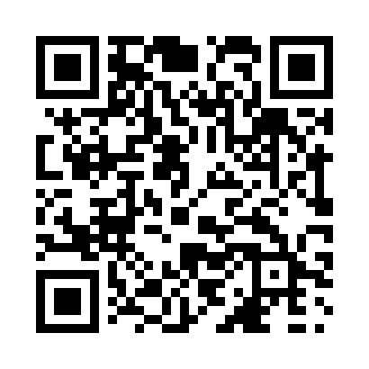
Prayer times for Buick, British Columbia, Canada
Wed 1 May 2024 - Fri 31 May 2024
High Latitude Method: Angle Based Rule
Prayer Calculation Method: Islamic Society of North America
Asar Calculation Method: Hanafi

Date | Day | Fajr | Sunrise | Dhuhr | Asr | Maghrib | Isha
1 | Wed | 3:09 | 5:16 | 1:02 | 6:16 | 8:49 | 10:56
2 | Thu | 3:08 | 5:14 | 1:02 | 6:17 | 8:51 | 10:57
3 | Fri | 3:07 | 5:12 | 1:02 | 6:19 | 8:53 | 10:58
4 | Sat | 3:06 | 5:09 | 1:02 | 6:20 | 8:55 | 10:59
5 | Sun | 3:05 | 5:07 | 1:02 | 6:21 | 8:57 | 11:00
6 | Mon | 3:04 | 5:05 | 1:02 | 6:22 | 8:59 | 11:01
7 | Tue | 3:02 | 5:03 | 1:02 | 6:23 | 9:02 | 11:02
8 | Wed | 3:01 | 5:01 | 1:02 | 6:25 | 9:04 | 11:03
9 | Thu | 3:00 | 4:58 | 1:02 | 6:26 | 9:06 | 11:04
10 | Fri | 2:59 | 4:56 | 1:01 | 6:27 | 9:08 | 11:05
11 | Sat | 2:58 | 4:54 | 1:01 | 6:28 | 9:10 | 11:06
12 | Sun | 2:57 | 4:52 | 1:01 | 6:29 | 9:12 | 11:07
13 | Mon | 2:56 | 4:50 | 1:01 | 6:30 | 9:14 | 11:08
14 | Tue | 2:55 | 4:48 | 1:01 | 6:31 | 9:15 | 11:09
15 | Wed | 2:54 | 4:46 | 1:01 | 6:33 | 9:17 | 11:10
16 | Thu | 2:53 | 4:45 | 1:02 | 6:34 | 9:19 | 11:11
17 | Fri | 2:52 | 4:43 | 1:02 | 6:35 | 9:21 | 11:12
18 | Sat | 2:52 | 4:41 | 1:02 | 6:36 | 9:23 | 11:13
19 | Sun | 2:51 | 4:39 | 1:02 | 6:37 | 9:25 | 11:14
20 | Mon | 2:50 | 4:38 | 1:02 | 6:38 | 9:27 | 11:14
21 | Tue | 2:49 | 4:36 | 1:02 | 6:39 | 9:29 | 11:15
22 | Wed | 2:48 | 4:34 | 1:02 | 6:40 | 9:30 | 11:16
23 | Thu | 2:48 | 4:33 | 1:02 | 6:41 | 9:32 | 11:17
24 | Fri | 2:47 | 4:31 | 1:02 | 6:42 | 9:34 | 11:18
25 | Sat | 2:46 | 4:30 | 1:02 | 6:43 | 9:35 | 11:19
26 | Sun | 2:45 | 4:28 | 1:02 | 6:43 | 9:37 | 11:20
27 | Mon | 2:45 | 4:27 | 1:02 | 6:44 | 9:39 | 11:21
28 | Tue | 2:44 | 4:26 | 1:03 | 6:45 | 9:40 | 11:22
29 | Wed | 2:44 | 4:24 | 1:03 | 6:46 | 9:42 | 11:22
30 | Thu | 2:43 | 4:23 | 1:03 | 6:47 | 9:43 | 11:23
31 | Fri | 2:43 | 4:22 | 1:03 | 6:48 | 9:45 | 11:24
Prayer times provided by https://www.salahtimes.com

