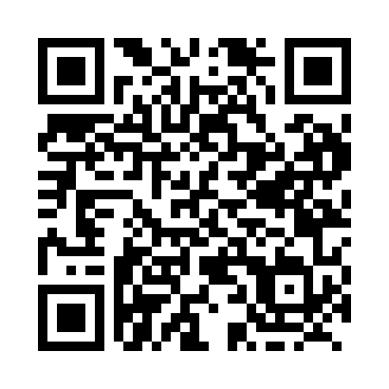
Prayer times for Klukshu, Yukon, Canada
Wed 1 May 2024 - Fri 31 May 2024
High Latitude Method: Angle Based Rule
Prayer Calculation Method: Islamic Society of North America
Asar Calculation Method: Hanafi

Date | Day | Fajr | Sunrise | Dhuhr | Asr | Maghrib | Isha
1 | Wed | 4:04 | 6:02 | 2:05 | 7:24 | 10:09 | 12:08
2 | Thu | 4:02 | 5:59 | 2:05 | 7:25 | 10:12 | 12:09
3 | Fri | 4:01 | 5:57 | 2:05 | 7:27 | 10:14 | 12:10
4 | Sat | 4:00 | 5:54 | 2:05 | 7:28 | 10:17 | 12:11
5 | Sun | 3:58 | 5:51 | 2:05 | 7:30 | 10:19 | 12:12
6 | Mon | 3:57 | 5:49 | 2:05 | 7:31 | 10:22 | 12:14
7 | Tue | 3:56 | 5:46 | 2:05 | 7:32 | 10:24 | 12:15
8 | Wed | 3:54 | 5:43 | 2:04 | 7:34 | 10:27 | 12:16
9 | Thu | 3:53 | 5:41 | 2:04 | 7:35 | 10:29 | 12:17
10 | Fri | 3:52 | 5:38 | 2:04 | 7:36 | 10:32 | 12:18
11 | Sat | 3:50 | 5:36 | 2:04 | 7:38 | 10:34 | 12:20
12 | Sun | 3:49 | 5:33 | 2:04 | 7:39 | 10:37 | 12:21
13 | Mon | 3:48 | 5:31 | 2:04 | 7:40 | 10:39 | 12:22
14 | Tue | 3:47 | 5:28 | 2:04 | 7:42 | 10:42 | 12:23
15 | Wed | 3:46 | 5:26 | 2:04 | 7:43 | 10:44 | 12:24
16 | Thu | 3:44 | 5:24 | 2:04 | 7:44 | 10:46 | 12:26
17 | Fri | 3:43 | 5:21 | 2:04 | 7:45 | 10:49 | 12:27
18 | Sat | 3:42 | 5:19 | 2:05 | 7:47 | 10:51 | 12:28
19 | Sun | 3:41 | 5:17 | 2:05 | 7:48 | 10:53 | 12:29
20 | Mon | 3:40 | 5:15 | 2:05 | 7:49 | 10:56 | 12:30
21 | Tue | 3:39 | 5:13 | 2:05 | 7:50 | 10:58 | 12:32
22 | Wed | 3:38 | 5:11 | 2:05 | 7:51 | 11:00 | 12:33
23 | Thu | 3:37 | 5:09 | 2:05 | 7:52 | 11:02 | 12:34
24 | Fri | 3:36 | 5:07 | 2:05 | 7:53 | 11:04 | 12:35
25 | Sat | 3:35 | 5:05 | 2:05 | 7:54 | 11:06 | 12:36
26 | Sun | 3:34 | 5:03 | 2:05 | 7:56 | 11:08 | 12:37
27 | Mon | 3:33 | 5:01 | 2:05 | 7:57 | 11:10 | 12:38
28 | Tue | 3:33 | 4:59 | 2:05 | 7:57 | 11:12 | 12:39
29 | Wed | 3:32 | 4:58 | 2:06 | 7:58 | 11:14 | 12:40
30 | Thu | 3:31 | 4:56 | 2:06 | 7:59 | 11:16 | 12:41
31 | Fri | 3:30 | 4:54 | 2:06 | 8:00 | 11:18 | 12:42
Prayer times provided by https://www.salahtimes.com

