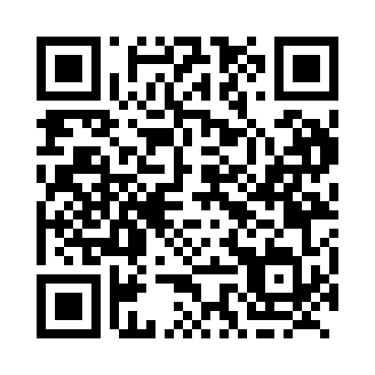
Prayer times for Gull Bay, Ontario, Canada
Wed 1 May 2024 - Fri 31 May 2024
High Latitude Method: Angle Based Rule
Prayer Calculation Method: Islamic Society of North America
Asar Calculation Method: Hanafi

Date | Day | Fajr | Sunrise | Dhuhr | Asr | Maghrib | Isha
1 | Wed | 4:43 | 6:32 | 1:53 | 6:59 | 9:16 | 11:06
2 | Thu | 4:40 | 6:30 | 1:53 | 7:00 | 9:17 | 11:08
3 | Fri | 4:38 | 6:29 | 1:53 | 7:01 | 9:19 | 11:10
4 | Sat | 4:35 | 6:27 | 1:53 | 7:02 | 9:20 | 11:13
5 | Sun | 4:32 | 6:25 | 1:53 | 7:03 | 9:22 | 11:15
6 | Mon | 4:30 | 6:24 | 1:53 | 7:04 | 9:23 | 11:17
7 | Tue | 4:27 | 6:22 | 1:53 | 7:05 | 9:25 | 11:20
8 | Wed | 4:25 | 6:21 | 1:53 | 7:05 | 9:26 | 11:22
9 | Thu | 4:22 | 6:19 | 1:53 | 7:06 | 9:27 | 11:25
10 | Fri | 4:20 | 6:17 | 1:53 | 7:07 | 9:29 | 11:27
11 | Sat | 4:17 | 6:16 | 1:53 | 7:08 | 9:30 | 11:30
12 | Sun | 4:15 | 6:15 | 1:53 | 7:09 | 9:32 | 11:32
13 | Mon | 4:12 | 6:13 | 1:53 | 7:10 | 9:33 | 11:35
14 | Tue | 4:10 | 6:12 | 1:53 | 7:11 | 9:35 | 11:37
15 | Wed | 4:07 | 6:10 | 1:53 | 7:11 | 9:36 | 11:40
16 | Thu | 4:05 | 6:09 | 1:53 | 7:12 | 9:37 | 11:42
17 | Fri | 4:02 | 6:08 | 1:53 | 7:13 | 9:39 | 11:45
18 | Sat | 4:00 | 6:06 | 1:53 | 7:14 | 9:40 | 11:47
19 | Sun | 3:59 | 6:05 | 1:53 | 7:15 | 9:41 | 11:47
20 | Mon | 3:59 | 6:04 | 1:53 | 7:15 | 9:43 | 11:48
21 | Tue | 3:58 | 6:03 | 1:53 | 7:16 | 9:44 | 11:49
22 | Wed | 3:58 | 6:02 | 1:53 | 7:17 | 9:45 | 11:49
23 | Thu | 3:57 | 6:01 | 1:53 | 7:18 | 9:46 | 11:50
24 | Fri | 3:57 | 6:00 | 1:53 | 7:18 | 9:48 | 11:51
25 | Sat | 3:56 | 5:59 | 1:53 | 7:19 | 9:49 | 11:51
26 | Sun | 3:56 | 5:58 | 1:54 | 7:20 | 9:50 | 11:52
27 | Mon | 3:55 | 5:57 | 1:54 | 7:20 | 9:51 | 11:53
28 | Tue | 3:55 | 5:56 | 1:54 | 7:21 | 9:52 | 11:53
29 | Wed | 3:55 | 5:55 | 1:54 | 7:22 | 9:53 | 11:54
30 | Thu | 3:54 | 5:54 | 1:54 | 7:22 | 9:54 | 11:54
31 | Fri | 3:54 | 5:53 | 1:54 | 7:23 | 9:56 | 11:55
Prayer times provided by https://www.salahtimes.com

