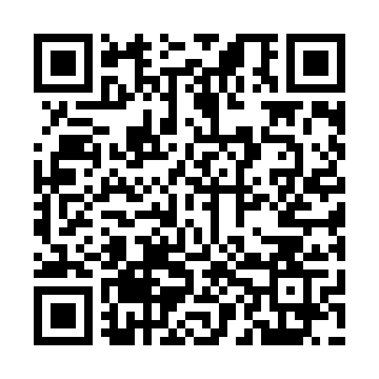
Prayer times for Char Mahiruddin, Bangladesh
Mon 1 Apr 2024 - Tue 30 Apr 2024
High Latitude Method: None
Prayer Calculation Method: University of Islamic Sciences
Asar Calculation Method: Shafi

Date | Day | Fajr | Sunrise | Dhuhr | Asr | Maghrib | Isha
1 | Mon | 4:36 | 5:51 | 12:02 | 3:28 | 6:13 | 7:28
2 | Tue | 4:35 | 5:50 | 12:01 | 3:27 | 6:13 | 7:29
3 | Wed | 4:34 | 5:49 | 12:01 | 3:27 | 6:14 | 7:29
4 | Thu | 4:33 | 5:48 | 12:01 | 3:27 | 6:14 | 7:29
5 | Fri | 4:32 | 5:47 | 12:01 | 3:26 | 6:14 | 7:30
6 | Sat | 4:31 | 5:46 | 12:00 | 3:26 | 6:15 | 7:30
7 | Sun | 4:30 | 5:45 | 12:00 | 3:26 | 6:15 | 7:31
8 | Mon | 4:29 | 5:44 | 12:00 | 3:25 | 6:15 | 7:31
9 | Tue | 4:28 | 5:43 | 11:59 | 3:25 | 6:16 | 7:32
10 | Wed | 4:27 | 5:42 | 11:59 | 3:25 | 6:16 | 7:32
11 | Thu | 4:26 | 5:42 | 11:59 | 3:24 | 6:16 | 7:33
12 | Fri | 4:25 | 5:41 | 11:59 | 3:24 | 6:17 | 7:33
13 | Sat | 4:24 | 5:40 | 11:58 | 3:24 | 6:17 | 7:34
14 | Sun | 4:23 | 5:39 | 11:58 | 3:23 | 6:18 | 7:34
15 | Mon | 4:22 | 5:38 | 11:58 | 3:23 | 6:18 | 7:35
16 | Tue | 4:21 | 5:37 | 11:58 | 3:23 | 6:18 | 7:35
17 | Wed | 4:20 | 5:37 | 11:57 | 3:22 | 6:19 | 7:36
18 | Thu | 4:19 | 5:36 | 11:57 | 3:22 | 6:19 | 7:36
19 | Fri | 4:18 | 5:35 | 11:57 | 3:22 | 6:19 | 7:37
20 | Sat | 4:17 | 5:34 | 11:57 | 3:21 | 6:20 | 7:37
21 | Sun | 4:16 | 5:33 | 11:57 | 3:21 | 6:20 | 7:38
22 | Mon | 4:15 | 5:33 | 11:56 | 3:20 | 6:21 | 7:38
23 | Tue | 4:14 | 5:32 | 11:56 | 3:20 | 6:21 | 7:39
24 | Wed | 4:13 | 5:31 | 11:56 | 3:20 | 6:21 | 7:39
25 | Thu | 4:12 | 5:30 | 11:56 | 3:19 | 6:22 | 7:40
26 | Fri | 4:11 | 5:30 | 11:56 | 3:19 | 6:22 | 7:41
27 | Sat | 4:10 | 5:29 | 11:56 | 3:19 | 6:22 | 7:41
28 | Sun | 4:09 | 5:28 | 11:55 | 3:18 | 6:23 | 7:42
29 | Mon | 4:09 | 5:27 | 11:55 | 3:18 | 6:23 | 7:42
30 | Tue | 4:08 | 5:27 | 11:55 | 3:18 | 6:24 | 7:43
Prayer times provided by https://www.salahtimes.com

