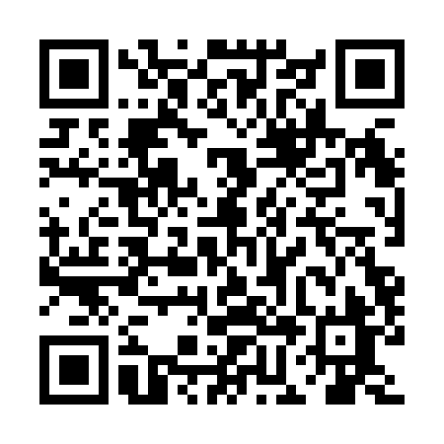
Prayer times for Wee Too Beach, Saskatchewan, Canada
Mon 1 Jul 2024 - Wed 31 Jul 2024
High Latitude Method: Angle Based Rule
Prayer Calculation Method: Islamic Society of North America
Asar Calculation Method: Hanafi

Date | Day | Fajr | Sunrise | Dhuhr | Asr | Maghrib | Isha
1 | Mon | 2:58 | 4:51 | 1:05 | 6:39 | 9:18 | 11:11
2 | Tue | 2:58 | 4:52 | 1:05 | 6:39 | 9:17 | 11:11
3 | Wed | 2:59 | 4:53 | 1:05 | 6:39 | 9:17 | 11:11
4 | Thu | 2:59 | 4:54 | 1:05 | 6:39 | 9:17 | 11:11
5 | Fri | 3:00 | 4:55 | 1:05 | 6:39 | 9:16 | 11:11
6 | Sat | 3:00 | 4:55 | 1:06 | 6:39 | 9:15 | 11:10
7 | Sun | 3:01 | 4:56 | 1:06 | 6:38 | 9:15 | 11:10
8 | Mon | 3:02 | 4:57 | 1:06 | 6:38 | 9:14 | 11:10
9 | Tue | 3:02 | 4:58 | 1:06 | 6:38 | 9:13 | 11:10
10 | Wed | 3:03 | 4:59 | 1:06 | 6:37 | 9:13 | 11:09
11 | Thu | 3:03 | 5:00 | 1:06 | 6:37 | 9:12 | 11:09
12 | Fri | 3:04 | 5:01 | 1:06 | 6:37 | 9:11 | 11:09
13 | Sat | 3:04 | 5:03 | 1:07 | 6:36 | 9:10 | 11:08
14 | Sun | 3:05 | 5:04 | 1:07 | 6:36 | 9:09 | 11:08
15 | Mon | 3:06 | 5:05 | 1:07 | 6:35 | 9:08 | 11:07
16 | Tue | 3:06 | 5:06 | 1:07 | 6:35 | 9:07 | 11:07
17 | Wed | 3:07 | 5:07 | 1:07 | 6:34 | 9:06 | 11:06
18 | Thu | 3:08 | 5:08 | 1:07 | 6:34 | 9:05 | 11:06
19 | Fri | 3:08 | 5:10 | 1:07 | 6:33 | 9:04 | 11:05
20 | Sat | 3:09 | 5:11 | 1:07 | 6:32 | 9:03 | 11:05
21 | Sun | 3:10 | 5:12 | 1:07 | 6:32 | 9:01 | 11:04
22 | Mon | 3:10 | 5:14 | 1:07 | 6:31 | 9:00 | 11:04
23 | Tue | 3:11 | 5:15 | 1:07 | 6:30 | 8:59 | 11:03
24 | Wed | 3:12 | 5:16 | 1:07 | 6:30 | 8:57 | 11:02
25 | Thu | 3:12 | 5:18 | 1:07 | 6:29 | 8:56 | 11:02
26 | Fri | 3:13 | 5:19 | 1:07 | 6:28 | 8:55 | 11:01
27 | Sat | 3:14 | 5:20 | 1:07 | 6:27 | 8:53 | 11:00
28 | Sun | 3:14 | 5:22 | 1:07 | 6:26 | 8:52 | 10:59
29 | Mon | 3:16 | 5:23 | 1:07 | 6:25 | 8:50 | 10:57
30 | Tue | 3:18 | 5:25 | 1:07 | 6:24 | 8:49 | 10:54
31 | Wed | 3:21 | 5:26 | 1:07 | 6:23 | 8:47 | 10:52
Prayer times provided by https://www.salahtimes.com

