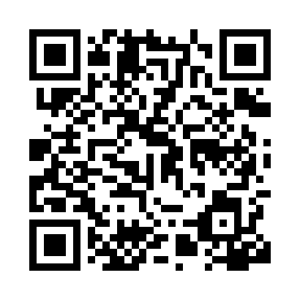
Prayer times for Samara, Russia
Wed 1 May 2024 - Fri 31 May 2024
High Latitude Method: Angle Based Rule
Prayer Calculation Method: Spiritual Administration of Muslims of Russia
Asar Calculation Method: Shafi

Date | Day | Fajr | Sunrise | Dhuhr | Asr | Maghrib | Isha
1 | Wed | 2:47 | 5:05 | 12:36 | 4:41 | 8:09 | 10:15
2 | Thu | 2:44 | 5:03 | 12:36 | 4:42 | 8:11 | 10:18
3 | Fri | 2:40 | 5:01 | 12:36 | 4:42 | 8:12 | 10:21
4 | Sat | 2:39 | 4:59 | 12:36 | 4:43 | 8:14 | 10:25
5 | Sun | 2:38 | 4:57 | 12:36 | 4:44 | 8:16 | 10:26
6 | Mon | 2:37 | 4:55 | 12:36 | 4:45 | 8:18 | 10:27
7 | Tue | 2:36 | 4:53 | 12:36 | 4:45 | 8:19 | 10:28
8 | Wed | 2:35 | 4:51 | 12:36 | 4:46 | 8:21 | 10:29
9 | Thu | 2:34 | 4:50 | 12:36 | 4:47 | 8:23 | 10:29
10 | Fri | 2:34 | 4:48 | 12:36 | 4:47 | 8:24 | 10:30
11 | Sat | 2:33 | 4:46 | 12:36 | 4:48 | 8:26 | 10:31
12 | Sun | 2:32 | 4:44 | 12:36 | 4:49 | 8:28 | 10:32
13 | Mon | 2:31 | 4:43 | 12:36 | 4:49 | 8:29 | 10:33
14 | Tue | 2:30 | 4:41 | 12:36 | 4:50 | 8:31 | 10:34
15 | Wed | 2:30 | 4:39 | 12:36 | 4:51 | 8:33 | 10:34
16 | Thu | 2:29 | 4:38 | 12:36 | 4:51 | 8:34 | 10:35
17 | Fri | 2:28 | 4:36 | 12:36 | 4:52 | 8:36 | 10:36
18 | Sat | 2:27 | 4:35 | 12:36 | 4:53 | 8:37 | 10:37
19 | Sun | 2:27 | 4:33 | 12:36 | 4:53 | 8:39 | 10:38
20 | Mon | 2:26 | 4:32 | 12:36 | 4:54 | 8:41 | 10:38
21 | Tue | 2:26 | 4:30 | 12:36 | 4:54 | 8:42 | 10:39
22 | Wed | 2:25 | 4:29 | 12:36 | 4:55 | 8:44 | 10:40
23 | Thu | 2:24 | 4:28 | 12:36 | 4:56 | 8:45 | 10:41
24 | Fri | 2:24 | 4:27 | 12:36 | 4:56 | 8:46 | 10:41
25 | Sat | 2:23 | 4:25 | 12:36 | 4:57 | 8:48 | 10:42
26 | Sun | 2:23 | 4:24 | 12:36 | 4:57 | 8:49 | 10:43
27 | Mon | 2:22 | 4:23 | 12:36 | 4:58 | 8:51 | 10:44
28 | Tue | 2:22 | 4:22 | 12:37 | 4:58 | 8:52 | 10:44
29 | Wed | 2:22 | 4:21 | 12:37 | 4:59 | 8:53 | 10:45
30 | Thu | 2:21 | 4:20 | 12:37 | 4:59 | 8:54 | 10:46
31 | Fri | 2:21 | 4:19 | 12:37 | 5:00 | 8:56 | 10:46
Prayer times provided by https://www.salahtimes.com

