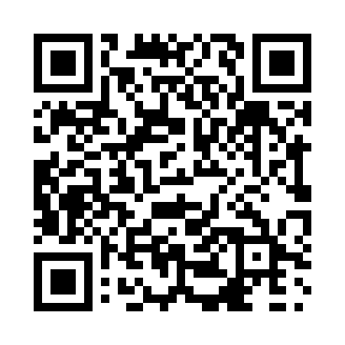
Prayer times for Sunningdale, British Columbia, Canada
Mon 1 Jul 2024 - Wed 31 Jul 2024
High Latitude Method: Angle Based Rule
Prayer Calculation Method: Islamic Society of North America
Asar Calculation Method: Hanafi

Date | Day | Fajr | Sunrise | Dhuhr | Asr | Maghrib | Isha
1 | Mon | 2:53 | 4:51 | 12:55 | 6:26 | 8:59 | 10:57
2 | Tue | 2:53 | 4:51 | 12:55 | 6:25 | 8:59 | 10:57
3 | Wed | 2:54 | 4:52 | 12:55 | 6:25 | 8:58 | 10:57
4 | Thu | 2:54 | 4:53 | 12:55 | 6:25 | 8:58 | 10:57
5 | Fri | 2:55 | 4:54 | 12:56 | 6:25 | 8:57 | 10:56
6 | Sat | 2:55 | 4:55 | 12:56 | 6:25 | 8:57 | 10:56
7 | Sun | 2:56 | 4:55 | 12:56 | 6:25 | 8:56 | 10:56
8 | Mon | 2:56 | 4:56 | 12:56 | 6:24 | 8:56 | 10:56
9 | Tue | 2:57 | 4:57 | 12:56 | 6:24 | 8:55 | 10:56
10 | Wed | 2:57 | 4:58 | 12:56 | 6:24 | 8:54 | 10:55
11 | Thu | 2:58 | 4:59 | 12:57 | 6:24 | 8:54 | 10:55
12 | Fri | 2:58 | 5:00 | 12:57 | 6:23 | 8:53 | 10:55
13 | Sat | 2:59 | 5:01 | 12:57 | 6:23 | 8:52 | 10:54
14 | Sun | 2:59 | 5:02 | 12:57 | 6:22 | 8:51 | 10:54
15 | Mon | 3:00 | 5:03 | 12:57 | 6:22 | 8:50 | 10:53
16 | Tue | 3:01 | 5:04 | 12:57 | 6:21 | 8:49 | 10:53
17 | Wed | 3:01 | 5:05 | 12:57 | 6:21 | 8:48 | 10:53
18 | Thu | 3:02 | 5:07 | 12:57 | 6:20 | 8:47 | 10:52
19 | Fri | 3:02 | 5:08 | 12:57 | 6:20 | 8:46 | 10:52
20 | Sat | 3:03 | 5:09 | 12:57 | 6:19 | 8:45 | 10:51
21 | Sun | 3:05 | 5:10 | 12:57 | 6:19 | 8:44 | 10:49
22 | Mon | 3:07 | 5:11 | 12:57 | 6:18 | 8:43 | 10:46
23 | Tue | 3:09 | 5:13 | 12:57 | 6:17 | 8:42 | 10:44
24 | Wed | 3:12 | 5:14 | 12:57 | 6:17 | 8:40 | 10:42
25 | Thu | 3:14 | 5:15 | 12:57 | 6:16 | 8:39 | 10:40
26 | Fri | 3:16 | 5:16 | 12:57 | 6:15 | 8:38 | 10:37
27 | Sat | 3:18 | 5:18 | 12:57 | 6:14 | 8:36 | 10:35
28 | Sun | 3:21 | 5:19 | 12:57 | 6:13 | 8:35 | 10:33
29 | Mon | 3:23 | 5:20 | 12:57 | 6:13 | 8:34 | 10:30
30 | Tue | 3:25 | 5:22 | 12:57 | 6:12 | 8:32 | 10:28
31 | Wed | 3:28 | 5:23 | 12:57 | 6:11 | 8:31 | 10:26
Prayer times provided by https://www.salahtimes.com

