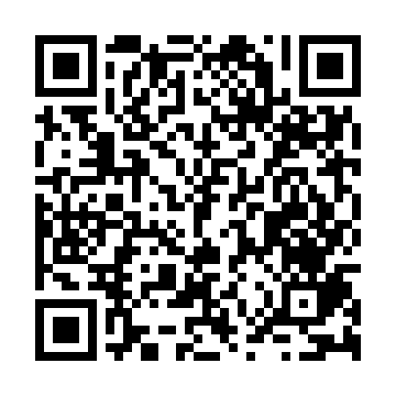
Prayer times for Nakhchivan, Azerbaijan
Wed 1 May 2024 - Fri 31 May 2024
High Latitude Method: None
Prayer Calculation Method: Muslim World League
Asar Calculation Method: Shafi

Date | Day | Fajr | Sunrise | Dhuhr | Asr | Maghrib | Isha
1 | Wed | 4:18 | 6:00 | 12:55 | 4:45 | 7:52 | 9:27
2 | Thu | 4:16 | 5:59 | 12:55 | 4:45 | 7:53 | 9:29
3 | Fri | 4:15 | 5:57 | 12:55 | 4:45 | 7:54 | 9:30
4 | Sat | 4:13 | 5:56 | 12:55 | 4:46 | 7:55 | 9:31
5 | Sun | 4:11 | 5:55 | 12:55 | 4:46 | 7:56 | 9:33
6 | Mon | 4:10 | 5:54 | 12:55 | 4:46 | 7:57 | 9:34
7 | Tue | 4:08 | 5:53 | 12:55 | 4:46 | 7:58 | 9:36
8 | Wed | 4:07 | 5:52 | 12:55 | 4:47 | 7:59 | 9:37
9 | Thu | 4:05 | 5:51 | 12:55 | 4:47 | 7:59 | 9:38
10 | Fri | 4:04 | 5:50 | 12:55 | 4:47 | 8:00 | 9:40
11 | Sat | 4:02 | 5:49 | 12:55 | 4:47 | 8:01 | 9:41
12 | Sun | 4:01 | 5:48 | 12:55 | 4:48 | 8:02 | 9:42
13 | Mon | 3:59 | 5:47 | 12:55 | 4:48 | 8:03 | 9:44
14 | Tue | 3:58 | 5:46 | 12:55 | 4:48 | 8:04 | 9:45
15 | Wed | 3:57 | 5:45 | 12:55 | 4:48 | 8:05 | 9:47
16 | Thu | 3:55 | 5:44 | 12:55 | 4:48 | 8:06 | 9:48
17 | Fri | 3:54 | 5:43 | 12:55 | 4:49 | 8:07 | 9:49
18 | Sat | 3:53 | 5:42 | 12:55 | 4:49 | 8:08 | 9:51
19 | Sun | 3:51 | 5:42 | 12:55 | 4:49 | 8:09 | 9:52
20 | Mon | 3:50 | 5:41 | 12:55 | 4:49 | 8:10 | 9:53
21 | Tue | 3:49 | 5:40 | 12:55 | 4:50 | 8:10 | 9:54
22 | Wed | 3:48 | 5:39 | 12:55 | 4:50 | 8:11 | 9:56
23 | Thu | 3:46 | 5:39 | 12:55 | 4:50 | 8:12 | 9:57
24 | Fri | 3:45 | 5:38 | 12:55 | 4:50 | 8:13 | 9:58
25 | Sat | 3:44 | 5:37 | 12:55 | 4:51 | 8:14 | 9:59
26 | Sun | 3:43 | 5:37 | 12:56 | 4:51 | 8:14 | 10:01
27 | Mon | 3:42 | 5:36 | 12:56 | 4:51 | 8:15 | 10:02
28 | Tue | 3:41 | 5:36 | 12:56 | 4:51 | 8:16 | 10:03
29 | Wed | 3:40 | 5:35 | 12:56 | 4:52 | 8:17 | 10:04
30 | Thu | 3:39 | 5:35 | 12:56 | 4:52 | 8:18 | 10:05
31 | Fri | 3:39 | 5:34 | 12:56 | 4:52 | 8:18 | 10:06
Prayer times provided by https://www.salahtimes.com

