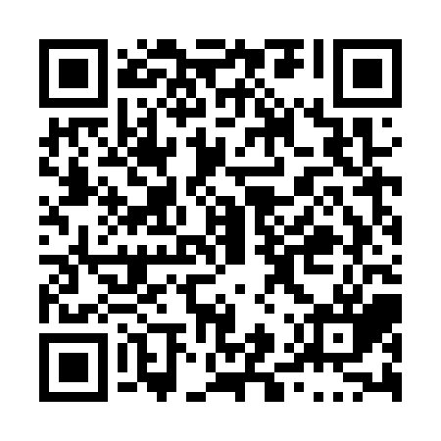
Prayer times for Tour-Bois-Blanc, Quebec, Canada
Wed 1 May 2024 - Fri 31 May 2024
High Latitude Method: Angle Based Rule
Prayer Calculation Method: Islamic Society of North America
Asar Calculation Method: Hanafi

Date | Day | Fajr | Sunrise | Dhuhr | Asr | Maghrib | Isha
1 | Wed | 3:13 | 5:03 | 12:25 | 5:31 | 7:48 | 9:39
2 | Thu | 3:10 | 5:01 | 12:25 | 5:32 | 7:49 | 9:41
3 | Fri | 3:08 | 5:00 | 12:25 | 5:33 | 7:51 | 9:43
4 | Sat | 3:05 | 4:58 | 12:25 | 5:34 | 7:52 | 9:46
5 | Sun | 3:03 | 4:56 | 12:25 | 5:35 | 7:54 | 9:48
6 | Mon | 3:00 | 4:55 | 12:25 | 5:35 | 7:55 | 9:51
7 | Tue | 2:57 | 4:53 | 12:25 | 5:36 | 7:57 | 9:53
8 | Wed | 2:55 | 4:51 | 12:24 | 5:37 | 7:58 | 9:56
9 | Thu | 2:52 | 4:50 | 12:24 | 5:38 | 8:00 | 9:58
10 | Fri | 2:50 | 4:48 | 12:24 | 5:39 | 8:01 | 10:01
11 | Sat | 2:47 | 4:47 | 12:24 | 5:40 | 8:03 | 10:03
12 | Sun | 2:44 | 4:45 | 12:24 | 5:41 | 8:04 | 10:06
13 | Mon | 2:42 | 4:44 | 12:24 | 5:42 | 8:06 | 10:08
14 | Tue | 2:39 | 4:43 | 12:24 | 5:42 | 8:07 | 10:11
15 | Wed | 2:37 | 4:41 | 12:24 | 5:43 | 8:08 | 10:13
16 | Thu | 2:34 | 4:40 | 12:24 | 5:44 | 8:10 | 10:16
17 | Fri | 2:32 | 4:38 | 12:24 | 5:45 | 8:11 | 10:18
18 | Sat | 2:31 | 4:37 | 12:24 | 5:46 | 8:12 | 10:19
19 | Sun | 2:30 | 4:36 | 12:25 | 5:47 | 8:14 | 10:19
20 | Mon | 2:30 | 4:35 | 12:25 | 5:47 | 8:15 | 10:20
21 | Tue | 2:29 | 4:34 | 12:25 | 5:48 | 8:16 | 10:21
22 | Wed | 2:29 | 4:32 | 12:25 | 5:49 | 8:18 | 10:21
23 | Thu | 2:28 | 4:31 | 12:25 | 5:50 | 8:19 | 10:22
24 | Fri | 2:28 | 4:30 | 12:25 | 5:50 | 8:20 | 10:23
25 | Sat | 2:27 | 4:29 | 12:25 | 5:51 | 8:21 | 10:23
26 | Sun | 2:27 | 4:28 | 12:25 | 5:52 | 8:23 | 10:24
27 | Mon | 2:26 | 4:27 | 12:25 | 5:52 | 8:24 | 10:25
28 | Tue | 2:26 | 4:26 | 12:25 | 5:53 | 8:25 | 10:25
29 | Wed | 2:26 | 4:26 | 12:26 | 5:54 | 8:26 | 10:26
30 | Thu | 2:25 | 4:25 | 12:26 | 5:54 | 8:27 | 10:26
31 | Fri | 2:25 | 4:24 | 12:26 | 5:55 | 8:28 | 10:27
Prayer times provided by https://www.salahtimes.com

