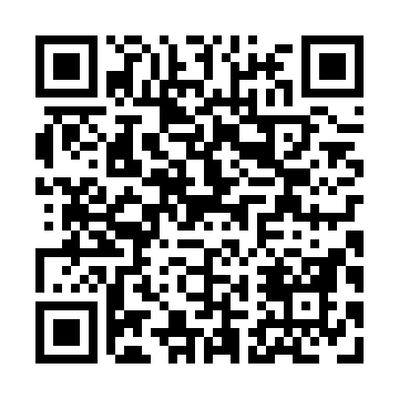
Prayer times for Clarke's Beach, Newfoundland and Labrador, Canada
Mon 1 Jul 2024 - Wed 31 Jul 2024
High Latitude Method: Angle Based Rule
Prayer Calculation Method: Islamic Society of North America
Asar Calculation Method: Hanafi

Date | Day | Fajr | Sunrise | Dhuhr | Asr | Maghrib | Isha
1 | Mon | 3:09 | 5:10 | 1:07 | 6:34 | 9:04 | 11:06
2 | Tue | 3:09 | 5:11 | 1:07 | 6:34 | 9:04 | 11:06
3 | Wed | 3:10 | 5:12 | 1:08 | 6:34 | 9:03 | 11:05
4 | Thu | 3:10 | 5:12 | 1:08 | 6:34 | 9:03 | 11:05
5 | Fri | 3:10 | 5:13 | 1:08 | 6:34 | 9:03 | 11:05
6 | Sat | 3:11 | 5:14 | 1:08 | 6:34 | 9:02 | 11:05
7 | Sun | 3:11 | 5:15 | 1:08 | 6:34 | 9:02 | 11:05
8 | Mon | 3:12 | 5:15 | 1:08 | 6:34 | 9:01 | 11:05
9 | Tue | 3:12 | 5:16 | 1:09 | 6:33 | 9:01 | 11:04
10 | Wed | 3:13 | 5:17 | 1:09 | 6:33 | 9:00 | 11:04
11 | Thu | 3:14 | 5:18 | 1:09 | 6:33 | 8:59 | 11:03
12 | Fri | 3:15 | 5:19 | 1:09 | 6:32 | 8:59 | 11:02
13 | Sat | 3:17 | 5:20 | 1:09 | 6:32 | 8:58 | 11:00
14 | Sun | 3:19 | 5:21 | 1:09 | 6:32 | 8:57 | 10:59
15 | Mon | 3:21 | 5:22 | 1:09 | 6:31 | 8:56 | 10:57
16 | Tue | 3:22 | 5:23 | 1:09 | 6:31 | 8:55 | 10:55
17 | Wed | 3:24 | 5:24 | 1:09 | 6:30 | 8:54 | 10:54
18 | Thu | 3:26 | 5:25 | 1:10 | 6:30 | 8:54 | 10:52
19 | Fri | 3:28 | 5:26 | 1:10 | 6:29 | 8:53 | 10:50
20 | Sat | 3:30 | 5:27 | 1:10 | 6:29 | 8:52 | 10:48
21 | Sun | 3:32 | 5:28 | 1:10 | 6:28 | 8:50 | 10:47
22 | Mon | 3:34 | 5:30 | 1:10 | 6:28 | 8:49 | 10:45
23 | Tue | 3:36 | 5:31 | 1:10 | 6:27 | 8:48 | 10:43
24 | Wed | 3:38 | 5:32 | 1:10 | 6:26 | 8:47 | 10:41
25 | Thu | 3:40 | 5:33 | 1:10 | 6:26 | 8:46 | 10:39
26 | Fri | 3:42 | 5:34 | 1:10 | 6:25 | 8:45 | 10:37
27 | Sat | 3:44 | 5:35 | 1:10 | 6:24 | 8:43 | 10:35
28 | Sun | 3:46 | 5:37 | 1:10 | 6:24 | 8:42 | 10:33
29 | Mon | 3:48 | 5:38 | 1:10 | 6:23 | 8:41 | 10:31
30 | Tue | 3:50 | 5:39 | 1:10 | 6:22 | 8:40 | 10:29
31 | Wed | 3:52 | 5:40 | 1:10 | 6:21 | 8:38 | 10:26
Prayer times provided by https://www.salahtimes.com

