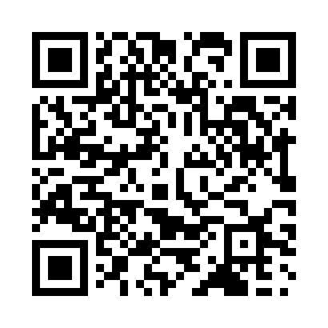
Prayer times for Curico, Chile
Wed 1 May 2024 - Fri 31 May 2024
High Latitude Method: None
Prayer Calculation Method: Muslim World League
Asar Calculation Method: Shafi

Date | Day | Fajr | Sunrise | Dhuhr | Asr | Maghrib | Isha
1 | Wed | 5:56 | 7:22 | 12:42 | 3:39 | 6:02 | 7:23
2 | Thu | 5:57 | 7:23 | 12:42 | 3:39 | 6:01 | 7:22
3 | Fri | 5:57 | 7:23 | 12:42 | 3:38 | 6:00 | 7:21
4 | Sat | 5:58 | 7:24 | 12:42 | 3:37 | 5:59 | 7:20
5 | Sun | 5:59 | 7:25 | 12:42 | 3:36 | 5:58 | 7:19
6 | Mon | 5:59 | 7:26 | 12:42 | 3:36 | 5:57 | 7:18
7 | Tue | 6:00 | 7:27 | 12:41 | 3:35 | 5:56 | 7:18
8 | Wed | 6:01 | 7:27 | 12:41 | 3:34 | 5:55 | 7:17
9 | Thu | 6:01 | 7:28 | 12:41 | 3:33 | 5:54 | 7:16
10 | Fri | 6:02 | 7:29 | 12:41 | 3:33 | 5:53 | 7:15
11 | Sat | 6:02 | 7:30 | 12:41 | 3:32 | 5:53 | 7:15
12 | Sun | 6:03 | 7:30 | 12:41 | 3:31 | 5:52 | 7:14
13 | Mon | 6:04 | 7:31 | 12:41 | 3:31 | 5:51 | 7:14
14 | Tue | 6:04 | 7:32 | 12:41 | 3:30 | 5:50 | 7:13
15 | Wed | 6:05 | 7:33 | 12:41 | 3:30 | 5:49 | 7:12
16 | Thu | 6:06 | 7:34 | 12:41 | 3:29 | 5:49 | 7:12
17 | Fri | 6:06 | 7:34 | 12:41 | 3:28 | 5:48 | 7:11
18 | Sat | 6:07 | 7:35 | 12:41 | 3:28 | 5:47 | 7:11
19 | Sun | 6:07 | 7:36 | 12:41 | 3:27 | 5:47 | 7:10
20 | Mon | 6:08 | 7:36 | 12:42 | 3:27 | 5:46 | 7:10
21 | Tue | 6:09 | 7:37 | 12:42 | 3:26 | 5:46 | 7:09
22 | Wed | 6:09 | 7:38 | 12:42 | 3:26 | 5:45 | 7:09
23 | Thu | 6:10 | 7:39 | 12:42 | 3:26 | 5:45 | 7:08
24 | Fri | 6:10 | 7:39 | 12:42 | 3:25 | 5:44 | 7:08
25 | Sat | 6:11 | 7:40 | 12:42 | 3:25 | 5:44 | 7:08
26 | Sun | 6:12 | 7:41 | 12:42 | 3:24 | 5:43 | 7:07
27 | Mon | 6:12 | 7:41 | 12:42 | 3:24 | 5:43 | 7:07
28 | Tue | 6:13 | 7:42 | 12:42 | 3:24 | 5:42 | 7:07
29 | Wed | 6:13 | 7:43 | 12:42 | 3:23 | 5:42 | 7:06
30 | Thu | 6:14 | 7:43 | 12:43 | 3:23 | 5:42 | 7:06
31 | Fri | 6:14 | 7:44 | 12:43 | 3:23 | 5:41 | 7:06
Prayer times provided by https://www.salahtimes.com

