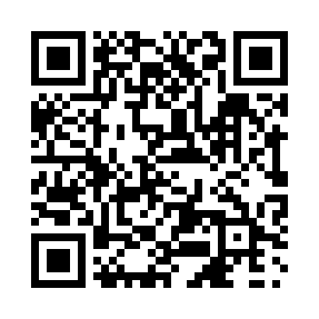
Prayer times for Tour-Maher, Quebec, Canada
Mon 1 Apr 2024 - Tue 30 Apr 2024
High Latitude Method: Angle Based Rule
Prayer Calculation Method: Islamic Society of North America
Asar Calculation Method: Hanafi

Date | Day | Fajr | Sunrise | Dhuhr | Asr | Maghrib | Isha
1 | Mon | 4:37 | 6:08 | 12:35 | 5:04 | 7:04 | 8:36
2 | Tue | 4:34 | 6:06 | 12:35 | 5:05 | 7:05 | 8:37
3 | Wed | 4:32 | 6:04 | 12:35 | 5:06 | 7:07 | 8:39
4 | Thu | 4:29 | 6:02 | 12:35 | 5:07 | 7:09 | 8:41
5 | Fri | 4:27 | 5:59 | 12:34 | 5:08 | 7:10 | 8:43
6 | Sat | 4:24 | 5:57 | 12:34 | 5:09 | 7:12 | 8:45
7 | Sun | 4:22 | 5:55 | 12:34 | 5:10 | 7:13 | 8:47
8 | Mon | 4:19 | 5:53 | 12:33 | 5:11 | 7:15 | 8:49
9 | Tue | 4:17 | 5:51 | 12:33 | 5:12 | 7:16 | 8:51
10 | Wed | 4:14 | 5:49 | 12:33 | 5:13 | 7:18 | 8:53
11 | Thu | 4:12 | 5:47 | 12:33 | 5:14 | 7:19 | 8:55
12 | Fri | 4:09 | 5:45 | 12:32 | 5:15 | 7:21 | 8:57
13 | Sat | 4:07 | 5:43 | 12:32 | 5:16 | 7:22 | 8:59
14 | Sun | 4:04 | 5:41 | 12:32 | 5:17 | 7:24 | 9:01
15 | Mon | 4:02 | 5:39 | 12:32 | 5:19 | 7:25 | 9:03
16 | Tue | 3:59 | 5:37 | 12:31 | 5:20 | 7:27 | 9:05
17 | Wed | 3:57 | 5:35 | 12:31 | 5:21 | 7:28 | 9:07
18 | Thu | 3:54 | 5:33 | 12:31 | 5:22 | 7:30 | 9:09
19 | Fri | 3:52 | 5:31 | 12:31 | 5:22 | 7:31 | 9:11
20 | Sat | 3:49 | 5:29 | 12:31 | 5:23 | 7:33 | 9:13
21 | Sun | 3:47 | 5:27 | 12:30 | 5:24 | 7:34 | 9:15
22 | Mon | 3:44 | 5:25 | 12:30 | 5:25 | 7:36 | 9:17
23 | Tue | 3:42 | 5:23 | 12:30 | 5:26 | 7:37 | 9:20
24 | Wed | 3:39 | 5:22 | 12:30 | 5:27 | 7:39 | 9:22
25 | Thu | 3:37 | 5:20 | 12:30 | 5:28 | 7:40 | 9:24
26 | Fri | 3:34 | 5:18 | 12:29 | 5:29 | 7:42 | 9:26
27 | Sat | 3:32 | 5:16 | 12:29 | 5:30 | 7:43 | 9:28
28 | Sun | 3:29 | 5:14 | 12:29 | 5:31 | 7:45 | 9:31
29 | Mon | 3:27 | 5:13 | 12:29 | 5:32 | 7:46 | 9:33
30 | Tue | 3:24 | 5:11 | 12:29 | 5:33 | 7:48 | 9:35
Prayer times provided by https://www.salahtimes.com

