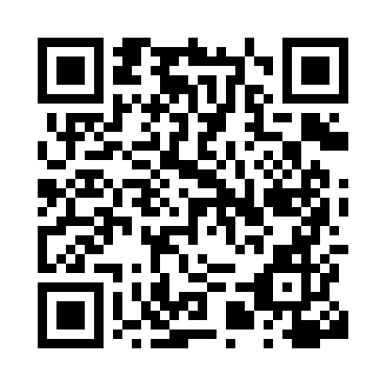
Prayer times for Lombia, France
Wed 1 May 2024 - Fri 31 May 2024
High Latitude Method: Angle Based Rule
Prayer Calculation Method: Islamic Organisations Union of France
Asar Calculation Method: Shafi

Date | Day | Fajr | Sunrise | Dhuhr | Asr | Maghrib | Isha
1 | Wed | 5:43 | 6:53 | 1:58 | 5:52 | 9:03 | 10:13
2 | Thu | 5:42 | 6:52 | 1:57 | 5:52 | 9:04 | 10:14
3 | Fri | 5:40 | 6:50 | 1:57 | 5:53 | 9:05 | 10:16
4 | Sat | 5:38 | 6:49 | 1:57 | 5:53 | 9:06 | 10:17
5 | Sun | 5:37 | 6:48 | 1:57 | 5:54 | 9:07 | 10:19
6 | Mon | 5:35 | 6:46 | 1:57 | 5:54 | 9:08 | 10:20
7 | Tue | 5:33 | 6:45 | 1:57 | 5:54 | 9:10 | 10:21
8 | Wed | 5:32 | 6:44 | 1:57 | 5:55 | 9:11 | 10:23
9 | Thu | 5:30 | 6:43 | 1:57 | 5:55 | 9:12 | 10:24
10 | Fri | 5:29 | 6:42 | 1:57 | 5:55 | 9:13 | 10:26
11 | Sat | 5:27 | 6:40 | 1:57 | 5:56 | 9:14 | 10:27
12 | Sun | 5:26 | 6:39 | 1:57 | 5:56 | 9:15 | 10:29
13 | Mon | 5:24 | 6:38 | 1:57 | 5:56 | 9:16 | 10:30
14 | Tue | 5:23 | 6:37 | 1:57 | 5:57 | 9:17 | 10:32
15 | Wed | 5:22 | 6:36 | 1:57 | 5:57 | 9:18 | 10:33
16 | Thu | 5:20 | 6:35 | 1:57 | 5:57 | 9:19 | 10:34
17 | Fri | 5:19 | 6:34 | 1:57 | 5:58 | 9:20 | 10:36
18 | Sat | 5:18 | 6:33 | 1:57 | 5:58 | 9:22 | 10:37
19 | Sun | 5:16 | 6:32 | 1:57 | 5:58 | 9:23 | 10:38
20 | Mon | 5:15 | 6:31 | 1:57 | 5:59 | 9:24 | 10:40
21 | Tue | 5:14 | 6:30 | 1:57 | 5:59 | 9:25 | 10:41
22 | Wed | 5:13 | 6:29 | 1:57 | 5:59 | 9:26 | 10:42
23 | Thu | 5:12 | 6:29 | 1:57 | 6:00 | 9:27 | 10:44
24 | Fri | 5:11 | 6:28 | 1:57 | 6:00 | 9:27 | 10:45
25 | Sat | 5:10 | 6:27 | 1:58 | 6:00 | 9:28 | 10:46
26 | Sun | 5:09 | 6:26 | 1:58 | 6:01 | 9:29 | 10:47
27 | Mon | 5:08 | 6:26 | 1:58 | 6:01 | 9:30 | 10:49
28 | Tue | 5:07 | 6:25 | 1:58 | 6:01 | 9:31 | 10:50
29 | Wed | 5:06 | 6:24 | 1:58 | 6:02 | 9:32 | 10:51
30 | Thu | 5:05 | 6:24 | 1:58 | 6:02 | 9:33 | 10:52
31 | Fri | 5:04 | 6:23 | 1:58 | 6:02 | 9:34 | 10:53
Prayer times provided by https://www.salahtimes.com

