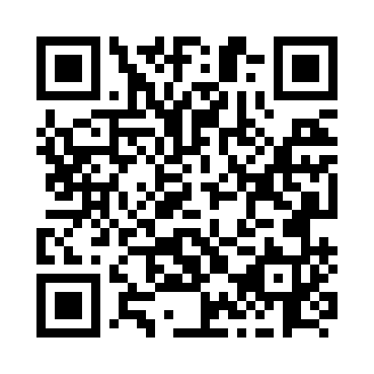
Prayer times for Cavendish, Newfoundland and Labrador, Canada
Mon 1 Jul 2024 - Wed 31 Jul 2024
High Latitude Method: Angle Based Rule
Prayer Calculation Method: Islamic Society of North America
Asar Calculation Method: Hanafi

Date | Day | Fajr | Sunrise | Dhuhr | Asr | Maghrib | Isha
1 | Mon | 3:09 | 5:10 | 1:08 | 6:36 | 9:06 | 11:07
2 | Tue | 3:09 | 5:11 | 1:08 | 6:36 | 9:05 | 11:07
3 | Wed | 3:10 | 5:11 | 1:08 | 6:36 | 9:05 | 11:07
4 | Thu | 3:10 | 5:12 | 1:09 | 6:35 | 9:05 | 11:07
5 | Fri | 3:11 | 5:13 | 1:09 | 6:35 | 9:04 | 11:06
6 | Sat | 3:11 | 5:14 | 1:09 | 6:35 | 9:04 | 11:06
7 | Sun | 3:12 | 5:15 | 1:09 | 6:35 | 9:03 | 11:06
8 | Mon | 3:12 | 5:15 | 1:09 | 6:35 | 9:03 | 11:06
9 | Tue | 3:13 | 5:16 | 1:09 | 6:34 | 9:02 | 11:06
10 | Wed | 3:13 | 5:17 | 1:09 | 6:34 | 9:01 | 11:05
11 | Thu | 3:14 | 5:18 | 1:10 | 6:34 | 9:01 | 11:05
12 | Fri | 3:14 | 5:19 | 1:10 | 6:34 | 9:00 | 11:04
13 | Sat | 3:16 | 5:20 | 1:10 | 6:33 | 8:59 | 11:03
14 | Sun | 3:18 | 5:21 | 1:10 | 6:33 | 8:59 | 11:01
15 | Mon | 3:19 | 5:22 | 1:10 | 6:32 | 8:58 | 11:00
16 | Tue | 3:21 | 5:23 | 1:10 | 6:32 | 8:57 | 10:58
17 | Wed | 3:23 | 5:24 | 1:10 | 6:31 | 8:56 | 10:56
18 | Thu | 3:25 | 5:25 | 1:10 | 6:31 | 8:55 | 10:54
19 | Fri | 3:27 | 5:26 | 1:10 | 6:30 | 8:54 | 10:53
20 | Sat | 3:29 | 5:27 | 1:10 | 6:30 | 8:53 | 10:51
21 | Sun | 3:31 | 5:28 | 1:10 | 6:29 | 8:52 | 10:49
22 | Mon | 3:33 | 5:30 | 1:10 | 6:29 | 8:51 | 10:47
23 | Tue | 3:35 | 5:31 | 1:11 | 6:28 | 8:50 | 10:45
24 | Wed | 3:37 | 5:32 | 1:11 | 6:27 | 8:49 | 10:43
25 | Thu | 3:39 | 5:33 | 1:11 | 6:27 | 8:47 | 10:41
26 | Fri | 3:41 | 5:34 | 1:11 | 6:26 | 8:46 | 10:39
27 | Sat | 3:43 | 5:36 | 1:11 | 6:25 | 8:45 | 10:37
28 | Sun | 3:45 | 5:37 | 1:10 | 6:25 | 8:44 | 10:35
29 | Mon | 3:47 | 5:38 | 1:10 | 6:24 | 8:42 | 10:33
30 | Tue | 3:49 | 5:39 | 1:10 | 6:23 | 8:41 | 10:31
31 | Wed | 3:51 | 5:41 | 1:10 | 6:22 | 8:39 | 10:29
Prayer times provided by https://www.salahtimes.com

