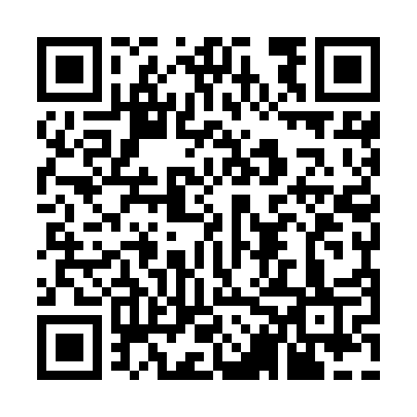
Prayer times for Longeville-sur-Mer, France
Wed 1 May 2024 - Fri 31 May 2024
High Latitude Method: Angle Based Rule
Prayer Calculation Method: Islamic Organisations Union of France
Asar Calculation Method: Shafi

Date | Day | Fajr | Sunrise | Dhuhr | Asr | Maghrib | Isha
1 | Wed | 5:36 | 6:51 | 2:03 | 6:01 | 9:16 | 10:31
2 | Thu | 5:34 | 6:50 | 2:03 | 6:01 | 9:17 | 10:33
3 | Fri | 5:32 | 6:48 | 2:03 | 6:02 | 9:18 | 10:34
4 | Sat | 5:30 | 6:47 | 2:03 | 6:02 | 9:19 | 10:36
5 | Sun | 5:28 | 6:45 | 2:03 | 6:03 | 9:21 | 10:38
6 | Mon | 5:27 | 6:44 | 2:03 | 6:03 | 9:22 | 10:40
7 | Tue | 5:25 | 6:42 | 2:03 | 6:04 | 9:23 | 10:41
8 | Wed | 5:23 | 6:41 | 2:02 | 6:04 | 9:25 | 10:43
9 | Thu | 5:21 | 6:40 | 2:02 | 6:05 | 9:26 | 10:45
10 | Fri | 5:19 | 6:38 | 2:02 | 6:05 | 9:27 | 10:46
11 | Sat | 5:18 | 6:37 | 2:02 | 6:05 | 9:28 | 10:48
12 | Sun | 5:16 | 6:36 | 2:02 | 6:06 | 9:30 | 10:50
13 | Mon | 5:14 | 6:34 | 2:02 | 6:06 | 9:31 | 10:51
14 | Tue | 5:13 | 6:33 | 2:02 | 6:07 | 9:32 | 10:53
15 | Wed | 5:11 | 6:32 | 2:02 | 6:07 | 9:33 | 10:55
16 | Thu | 5:09 | 6:31 | 2:02 | 6:08 | 9:34 | 10:56
17 | Fri | 5:08 | 6:30 | 2:02 | 6:08 | 9:36 | 10:58
18 | Sat | 5:06 | 6:29 | 2:02 | 6:09 | 9:37 | 11:00
19 | Sun | 5:05 | 6:28 | 2:03 | 6:09 | 9:38 | 11:01
20 | Mon | 5:03 | 6:27 | 2:03 | 6:09 | 9:39 | 11:03
21 | Tue | 5:02 | 6:26 | 2:03 | 6:10 | 9:40 | 11:04
22 | Wed | 5:00 | 6:25 | 2:03 | 6:10 | 9:41 | 11:06
23 | Thu | 4:59 | 6:24 | 2:03 | 6:11 | 9:42 | 11:07
24 | Fri | 4:58 | 6:23 | 2:03 | 6:11 | 9:44 | 11:09
25 | Sat | 4:56 | 6:22 | 2:03 | 6:11 | 9:45 | 11:10
26 | Sun | 4:55 | 6:21 | 2:03 | 6:12 | 9:46 | 11:12
27 | Mon | 4:54 | 6:20 | 2:03 | 6:12 | 9:47 | 11:13
28 | Tue | 4:53 | 6:20 | 2:03 | 6:13 | 9:48 | 11:15
29 | Wed | 4:52 | 6:19 | 2:03 | 6:13 | 9:49 | 11:16
30 | Thu | 4:51 | 6:18 | 2:04 | 6:13 | 9:49 | 11:17
31 | Fri | 4:50 | 6:18 | 2:04 | 6:14 | 9:50 | 11:19
Prayer times provided by https://www.salahtimes.com

