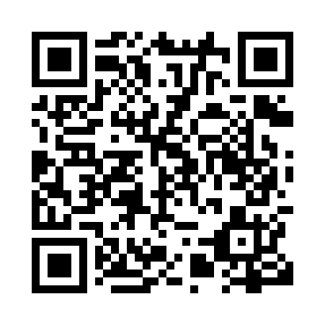
Prayer times for Zeneta, Saskatchewan, Canada
Wed 1 May 2024 - Fri 31 May 2024
High Latitude Method: Angle Based Rule
Prayer Calculation Method: Islamic Society of North America
Asar Calculation Method: Hanafi

Date | Day | Fajr | Sunrise | Dhuhr | Asr | Maghrib | Isha
1 | Wed | 3:28 | 5:21 | 12:45 | 5:52 | 8:10 | 10:04
2 | Thu | 3:25 | 5:19 | 12:45 | 5:53 | 8:12 | 10:07
3 | Fri | 3:22 | 5:18 | 12:45 | 5:54 | 8:13 | 10:09
4 | Sat | 3:20 | 5:16 | 12:45 | 5:55 | 8:15 | 10:12
5 | Sun | 3:17 | 5:14 | 12:45 | 5:56 | 8:17 | 10:14
6 | Mon | 3:14 | 5:12 | 12:45 | 5:57 | 8:18 | 10:17
7 | Tue | 3:11 | 5:11 | 12:45 | 5:58 | 8:20 | 10:20
8 | Wed | 3:09 | 5:09 | 12:45 | 5:59 | 8:21 | 10:22
9 | Thu | 3:06 | 5:08 | 12:45 | 6:00 | 8:23 | 10:25
10 | Fri | 3:03 | 5:06 | 12:45 | 6:00 | 8:24 | 10:28
11 | Sat | 3:00 | 5:04 | 12:45 | 6:01 | 8:26 | 10:30
12 | Sun | 2:58 | 5:03 | 12:45 | 6:02 | 8:27 | 10:33
13 | Mon | 2:55 | 5:01 | 12:45 | 6:03 | 8:29 | 10:36
14 | Tue | 2:52 | 5:00 | 12:45 | 6:04 | 8:30 | 10:38
15 | Wed | 2:52 | 4:58 | 12:45 | 6:05 | 8:32 | 10:38
16 | Thu | 2:51 | 4:57 | 12:45 | 6:06 | 8:33 | 10:39
17 | Fri | 2:50 | 4:56 | 12:45 | 6:06 | 8:34 | 10:40
18 | Sat | 2:50 | 4:54 | 12:45 | 6:07 | 8:36 | 10:40
19 | Sun | 2:49 | 4:53 | 12:45 | 6:08 | 8:37 | 10:41
20 | Mon | 2:49 | 4:52 | 12:45 | 6:09 | 8:39 | 10:42
21 | Tue | 2:48 | 4:51 | 12:45 | 6:10 | 8:40 | 10:43
22 | Wed | 2:47 | 4:49 | 12:45 | 6:10 | 8:41 | 10:43
23 | Thu | 2:47 | 4:48 | 12:45 | 6:11 | 8:42 | 10:44
24 | Fri | 2:46 | 4:47 | 12:45 | 6:12 | 8:44 | 10:45
25 | Sat | 2:46 | 4:46 | 12:45 | 6:13 | 8:45 | 10:45
26 | Sun | 2:45 | 4:45 | 12:45 | 6:13 | 8:46 | 10:46
27 | Mon | 2:45 | 4:44 | 12:46 | 6:14 | 8:47 | 10:47
28 | Tue | 2:45 | 4:43 | 12:46 | 6:15 | 8:49 | 10:47
29 | Wed | 2:44 | 4:42 | 12:46 | 6:16 | 8:50 | 10:48
30 | Thu | 2:44 | 4:42 | 12:46 | 6:16 | 8:51 | 10:48
31 | Fri | 2:44 | 4:41 | 12:46 | 6:17 | 8:52 | 10:49
Prayer times provided by https://www.salahtimes.com

