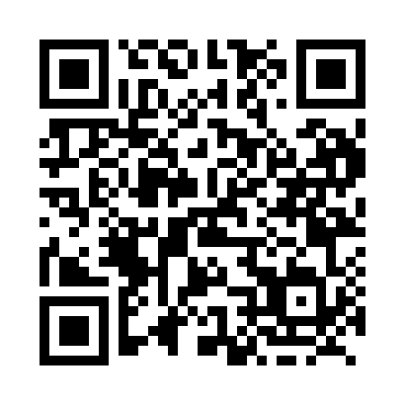
Prayer times for Dell, Quebec, Canada
Wed 1 May 2024 - Fri 31 May 2024
High Latitude Method: Angle Based Rule
Prayer Calculation Method: Islamic Society of North America
Asar Calculation Method: Hanafi

Date | Day | Fajr | Sunrise | Dhuhr | Asr | Maghrib | Isha
1 | Wed | 3:56 | 5:32 | 12:42 | 5:43 | 7:52 | 9:29
2 | Thu | 3:54 | 5:30 | 12:42 | 5:44 | 7:54 | 9:31
3 | Fri | 3:52 | 5:29 | 12:42 | 5:44 | 7:55 | 9:32
4 | Sat | 3:50 | 5:27 | 12:42 | 5:45 | 7:56 | 9:34
5 | Sun | 3:48 | 5:26 | 12:41 | 5:46 | 7:58 | 9:36
6 | Mon | 3:46 | 5:25 | 12:41 | 5:47 | 7:59 | 9:38
7 | Tue | 3:44 | 5:23 | 12:41 | 5:47 | 8:00 | 9:40
8 | Wed | 3:42 | 5:22 | 12:41 | 5:48 | 8:01 | 9:41
9 | Thu | 3:40 | 5:21 | 12:41 | 5:49 | 8:02 | 9:43
10 | Fri | 3:38 | 5:19 | 12:41 | 5:50 | 8:04 | 9:45
11 | Sat | 3:36 | 5:18 | 12:41 | 5:50 | 8:05 | 9:47
12 | Sun | 3:35 | 5:17 | 12:41 | 5:51 | 8:06 | 9:49
13 | Mon | 3:33 | 5:16 | 12:41 | 5:52 | 8:07 | 9:51
14 | Tue | 3:31 | 5:14 | 12:41 | 5:52 | 8:08 | 9:52
15 | Wed | 3:29 | 5:13 | 12:41 | 5:53 | 8:10 | 9:54
16 | Thu | 3:27 | 5:12 | 12:41 | 5:54 | 8:11 | 9:56
17 | Fri | 3:26 | 5:11 | 12:41 | 5:54 | 8:12 | 9:58
18 | Sat | 3:24 | 5:10 | 12:41 | 5:55 | 8:13 | 9:59
19 | Sun | 3:22 | 5:09 | 12:41 | 5:56 | 8:14 | 10:01
20 | Mon | 3:21 | 5:08 | 12:41 | 5:56 | 8:15 | 10:03
21 | Tue | 3:19 | 5:07 | 12:41 | 5:57 | 8:16 | 10:05
22 | Wed | 3:18 | 5:06 | 12:42 | 5:58 | 8:17 | 10:06
23 | Thu | 3:16 | 5:05 | 12:42 | 5:58 | 8:18 | 10:08
24 | Fri | 3:15 | 5:04 | 12:42 | 5:59 | 8:20 | 10:10
25 | Sat | 3:13 | 5:04 | 12:42 | 6:00 | 8:21 | 10:11
26 | Sun | 3:12 | 5:03 | 12:42 | 6:00 | 8:22 | 10:13
27 | Mon | 3:11 | 5:02 | 12:42 | 6:01 | 8:22 | 10:14
28 | Tue | 3:09 | 5:01 | 12:42 | 6:01 | 8:23 | 10:16
29 | Wed | 3:08 | 5:01 | 12:42 | 6:02 | 8:24 | 10:17
30 | Thu | 3:07 | 5:00 | 12:42 | 6:02 | 8:25 | 10:19
31 | Fri | 3:06 | 4:59 | 12:43 | 6:03 | 8:26 | 10:20
Prayer times provided by https://www.salahtimes.com

