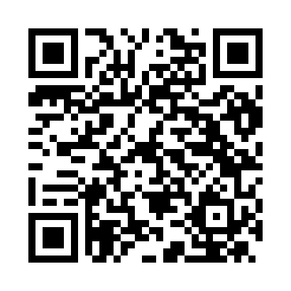
Prayer times for Albisano, Italy
Wed 1 May 2024 - Fri 31 May 2024
High Latitude Method: Angle Based Rule
Prayer Calculation Method: Muslim World League
Asar Calculation Method: Hanafi

Date | Day | Fajr | Sunrise | Dhuhr | Asr | Maghrib | Isha
1 | Wed | 4:05 | 6:05 | 1:14 | 6:15 | 8:25 | 10:17
2 | Thu | 4:03 | 6:03 | 1:14 | 6:16 | 8:26 | 10:19
3 | Fri | 4:00 | 6:02 | 1:14 | 6:17 | 8:27 | 10:20
4 | Sat | 3:58 | 6:00 | 1:14 | 6:17 | 8:28 | 10:22
5 | Sun | 3:56 | 5:59 | 1:14 | 6:18 | 8:30 | 10:24
6 | Mon | 3:54 | 5:57 | 1:14 | 6:19 | 8:31 | 10:26
7 | Tue | 3:51 | 5:56 | 1:14 | 6:20 | 8:32 | 10:28
8 | Wed | 3:49 | 5:55 | 1:14 | 6:20 | 8:33 | 10:30
9 | Thu | 3:47 | 5:53 | 1:14 | 6:21 | 8:35 | 10:32
10 | Fri | 3:45 | 5:52 | 1:14 | 6:22 | 8:36 | 10:34
11 | Sat | 3:43 | 5:51 | 1:14 | 6:23 | 8:37 | 10:36
12 | Sun | 3:40 | 5:49 | 1:14 | 6:23 | 8:38 | 10:39
13 | Mon | 3:38 | 5:48 | 1:14 | 6:24 | 8:39 | 10:41
14 | Tue | 3:36 | 5:47 | 1:14 | 6:25 | 8:41 | 10:43
15 | Wed | 3:34 | 5:46 | 1:14 | 6:25 | 8:42 | 10:45
16 | Thu | 3:32 | 5:45 | 1:14 | 6:26 | 8:43 | 10:47
17 | Fri | 3:30 | 5:44 | 1:14 | 6:27 | 8:44 | 10:48
18 | Sat | 3:28 | 5:43 | 1:14 | 6:27 | 8:45 | 10:50
19 | Sun | 3:26 | 5:42 | 1:14 | 6:28 | 8:46 | 10:52
20 | Mon | 3:24 | 5:41 | 1:14 | 6:29 | 8:47 | 10:54
21 | Tue | 3:22 | 5:40 | 1:14 | 6:29 | 8:49 | 10:56
22 | Wed | 3:20 | 5:39 | 1:14 | 6:30 | 8:50 | 10:58
23 | Thu | 3:18 | 5:38 | 1:14 | 6:31 | 8:51 | 11:00
24 | Fri | 3:16 | 5:37 | 1:14 | 6:31 | 8:52 | 11:02
25 | Sat | 3:14 | 5:36 | 1:14 | 6:32 | 8:53 | 11:04
26 | Sun | 3:12 | 5:35 | 1:14 | 6:32 | 8:54 | 11:06
27 | Mon | 3:11 | 5:35 | 1:14 | 6:33 | 8:55 | 11:07
28 | Tue | 3:09 | 5:34 | 1:15 | 6:34 | 8:56 | 11:09
29 | Wed | 3:07 | 5:33 | 1:15 | 6:34 | 8:57 | 11:11
30 | Thu | 3:06 | 5:32 | 1:15 | 6:35 | 8:58 | 11:13
31 | Fri | 3:04 | 5:32 | 1:15 | 6:35 | 8:58 | 11:14
Prayer times provided by https://www.salahtimes.com

