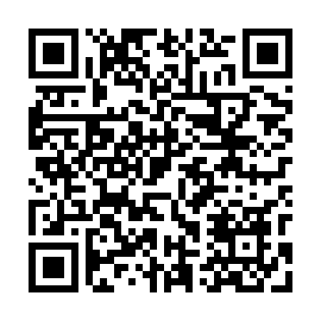
Prayer times for Leka Zabiecka, Poland
Wed 1 May 2024 - Fri 31 May 2024
High Latitude Method: Angle Based Rule
Prayer Calculation Method: Muslim World League
Asar Calculation Method: Hanafi

Date | Day | Fajr | Sunrise | Dhuhr | Asr | Maghrib | Isha
1 | Wed | 2:49 | 5:10 | 12:33 | 5:39 | 7:56 | 10:08
2 | Thu | 2:45 | 5:09 | 12:33 | 5:40 | 7:57 | 10:10
3 | Fri | 2:42 | 5:07 | 12:32 | 5:40 | 7:59 | 10:13
4 | Sat | 2:39 | 5:05 | 12:32 | 5:41 | 8:00 | 10:16
5 | Sun | 2:36 | 5:03 | 12:32 | 5:42 | 8:02 | 10:19
6 | Mon | 2:32 | 5:02 | 12:32 | 5:43 | 8:04 | 10:22
7 | Tue | 2:29 | 5:00 | 12:32 | 5:44 | 8:05 | 10:25
8 | Wed | 2:26 | 4:58 | 12:32 | 5:45 | 8:07 | 10:28
9 | Thu | 2:22 | 4:57 | 12:32 | 5:46 | 8:08 | 10:31
10 | Fri | 2:19 | 4:55 | 12:32 | 5:47 | 8:10 | 10:34
11 | Sat | 2:17 | 4:54 | 12:32 | 5:48 | 8:11 | 10:37
12 | Sun | 2:16 | 4:52 | 12:32 | 5:49 | 8:13 | 10:40
13 | Mon | 2:16 | 4:51 | 12:32 | 5:50 | 8:14 | 10:40
14 | Tue | 2:15 | 4:49 | 12:32 | 5:50 | 8:15 | 10:41
15 | Wed | 2:15 | 4:48 | 12:32 | 5:51 | 8:17 | 10:42
16 | Thu | 2:14 | 4:47 | 12:32 | 5:52 | 8:18 | 10:42
17 | Fri | 2:14 | 4:45 | 12:32 | 5:53 | 8:20 | 10:43
18 | Sat | 2:13 | 4:44 | 12:32 | 5:54 | 8:21 | 10:43
19 | Sun | 2:13 | 4:43 | 12:32 | 5:54 | 8:22 | 10:44
20 | Mon | 2:12 | 4:41 | 12:32 | 5:55 | 8:24 | 10:45
21 | Tue | 2:12 | 4:40 | 12:32 | 5:56 | 8:25 | 10:45
22 | Wed | 2:11 | 4:39 | 12:32 | 5:57 | 8:26 | 10:46
23 | Thu | 2:11 | 4:38 | 12:32 | 5:58 | 8:28 | 10:47
24 | Fri | 2:10 | 4:37 | 12:33 | 5:58 | 8:29 | 10:47
25 | Sat | 2:10 | 4:36 | 12:33 | 5:59 | 8:30 | 10:48
26 | Sun | 2:10 | 4:35 | 12:33 | 6:00 | 8:31 | 10:48
27 | Mon | 2:09 | 4:34 | 12:33 | 6:00 | 8:32 | 10:49
28 | Tue | 2:09 | 4:33 | 12:33 | 6:01 | 8:34 | 10:49
29 | Wed | 2:09 | 4:32 | 12:33 | 6:02 | 8:35 | 10:50
30 | Thu | 2:09 | 4:31 | 12:33 | 6:03 | 8:36 | 10:51
31 | Fri | 2:08 | 4:30 | 12:33 | 6:03 | 8:37 | 10:51
Prayer times provided by https://www.salahtimes.com

