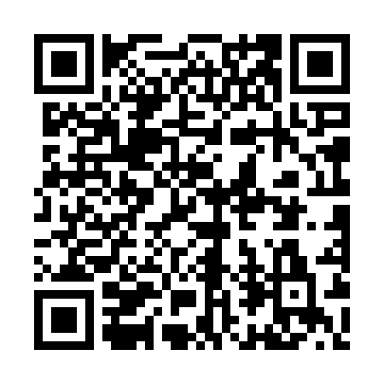
Prayer times for Bonghwa County, South Korea
Mon 1 Apr 2024 - Tue 30 Apr 2024
High Latitude Method: None
Prayer Calculation Method: Muslim World League
Asar Calculation Method: Shafi

Date | Day | Fajr | Sunrise | Dhuhr | Asr | Maghrib | Isha
1 | Mon | 4:43 | 6:11 | 12:29 | 4:03 | 6:48 | 8:11
2 | Tue | 4:41 | 6:10 | 12:29 | 4:03 | 6:48 | 8:12
3 | Wed | 4:39 | 6:08 | 12:28 | 4:04 | 6:49 | 8:13
4 | Thu | 4:38 | 6:07 | 12:28 | 4:04 | 6:50 | 8:14
5 | Fri | 4:36 | 6:05 | 12:28 | 4:04 | 6:51 | 8:15
6 | Sat | 4:34 | 6:04 | 12:28 | 4:04 | 6:52 | 8:16
7 | Sun | 4:33 | 6:02 | 12:27 | 4:05 | 6:53 | 8:17
8 | Mon | 4:31 | 6:01 | 12:27 | 4:05 | 6:54 | 8:18
9 | Tue | 4:29 | 5:59 | 12:27 | 4:05 | 6:55 | 8:19
10 | Wed | 4:28 | 5:58 | 12:26 | 4:05 | 6:55 | 8:20
11 | Thu | 4:26 | 5:57 | 12:26 | 4:05 | 6:56 | 8:22
12 | Fri | 4:24 | 5:55 | 12:26 | 4:06 | 6:57 | 8:23
13 | Sat | 4:23 | 5:54 | 12:26 | 4:06 | 6:58 | 8:24
14 | Sun | 4:21 | 5:52 | 12:25 | 4:06 | 6:59 | 8:25
15 | Mon | 4:19 | 5:51 | 12:25 | 4:06 | 7:00 | 8:26
16 | Tue | 4:18 | 5:50 | 12:25 | 4:06 | 7:01 | 8:27
17 | Wed | 4:16 | 5:48 | 12:25 | 4:07 | 7:02 | 8:28
18 | Thu | 4:14 | 5:47 | 12:24 | 4:07 | 7:02 | 8:29
19 | Fri | 4:13 | 5:46 | 12:24 | 4:07 | 7:03 | 8:31
20 | Sat | 4:11 | 5:44 | 12:24 | 4:07 | 7:04 | 8:32
21 | Sun | 4:10 | 5:43 | 12:24 | 4:07 | 7:05 | 8:33
22 | Mon | 4:08 | 5:42 | 12:24 | 4:07 | 7:06 | 8:34
23 | Tue | 4:06 | 5:41 | 12:23 | 4:08 | 7:07 | 8:35
24 | Wed | 4:05 | 5:39 | 12:23 | 4:08 | 7:08 | 8:37
25 | Thu | 4:03 | 5:38 | 12:23 | 4:08 | 7:09 | 8:38
26 | Fri | 4:02 | 5:37 | 12:23 | 4:08 | 7:10 | 8:39
27 | Sat | 4:00 | 5:36 | 12:23 | 4:08 | 7:10 | 8:40
28 | Sun | 3:59 | 5:34 | 12:23 | 4:08 | 7:11 | 8:41
29 | Mon | 3:57 | 5:33 | 12:22 | 4:08 | 7:12 | 8:43
30 | Tue | 3:55 | 5:32 | 12:22 | 4:09 | 7:13 | 8:44
Prayer times provided by https://www.salahtimes.com

