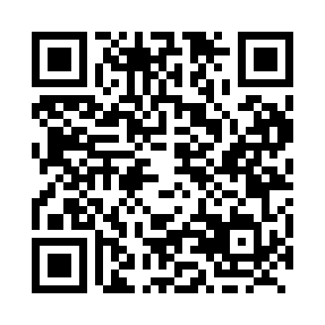
Prayer times for Aquadell, Saskatchewan, Canada
Wed 1 May 2024 - Fri 31 May 2024
High Latitude Method: Angle Based Rule
Prayer Calculation Method: Islamic Society of North America
Asar Calculation Method: Hanafi

Date | Day | Fajr | Sunrise | Dhuhr | Asr | Maghrib | Isha
1 | Wed | 3:47 | 5:40 | 1:04 | 6:11 | 8:29 | 10:22
2 | Thu | 3:45 | 5:39 | 1:04 | 6:12 | 8:30 | 10:25
3 | Fri | 3:42 | 5:37 | 1:04 | 6:13 | 8:32 | 10:27
4 | Sat | 3:39 | 5:35 | 1:04 | 6:14 | 8:34 | 10:30
5 | Sun | 3:37 | 5:33 | 1:04 | 6:15 | 8:35 | 10:32
6 | Mon | 3:34 | 5:32 | 1:04 | 6:15 | 8:37 | 10:35
7 | Tue | 3:31 | 5:30 | 1:04 | 6:16 | 8:38 | 10:38
8 | Wed | 3:28 | 5:28 | 1:04 | 6:17 | 8:40 | 10:40
9 | Thu | 3:26 | 5:27 | 1:04 | 6:18 | 8:41 | 10:43
10 | Fri | 3:23 | 5:25 | 1:04 | 6:19 | 8:43 | 10:46
11 | Sat | 3:20 | 5:24 | 1:04 | 6:20 | 8:44 | 10:48
12 | Sun | 3:18 | 5:22 | 1:03 | 6:21 | 8:46 | 10:51
13 | Mon | 3:15 | 5:21 | 1:03 | 6:22 | 8:47 | 10:54
14 | Tue | 3:12 | 5:19 | 1:04 | 6:23 | 8:49 | 10:56
15 | Wed | 3:11 | 5:18 | 1:04 | 6:23 | 8:50 | 10:57
16 | Thu | 3:10 | 5:16 | 1:04 | 6:24 | 8:51 | 10:58
17 | Fri | 3:09 | 5:15 | 1:04 | 6:25 | 8:53 | 10:58
18 | Sat | 3:09 | 5:14 | 1:04 | 6:26 | 8:54 | 10:59
19 | Sun | 3:08 | 5:12 | 1:04 | 6:27 | 8:56 | 11:00
20 | Mon | 3:08 | 5:11 | 1:04 | 6:28 | 8:57 | 11:01
21 | Tue | 3:07 | 5:10 | 1:04 | 6:28 | 8:58 | 11:01
22 | Wed | 3:06 | 5:09 | 1:04 | 6:29 | 9:00 | 11:02
23 | Thu | 3:06 | 5:08 | 1:04 | 6:30 | 9:01 | 11:03
24 | Fri | 3:05 | 5:07 | 1:04 | 6:31 | 9:02 | 11:03
25 | Sat | 3:05 | 5:06 | 1:04 | 6:31 | 9:03 | 11:04
26 | Sun | 3:05 | 5:05 | 1:04 | 6:32 | 9:05 | 11:05
27 | Mon | 3:04 | 5:04 | 1:04 | 6:33 | 9:06 | 11:05
28 | Tue | 3:04 | 5:03 | 1:05 | 6:34 | 9:07 | 11:06
29 | Wed | 3:03 | 5:02 | 1:05 | 6:34 | 9:08 | 11:06
30 | Thu | 3:03 | 5:01 | 1:05 | 6:35 | 9:09 | 11:07
31 | Fri | 3:03 | 5:00 | 1:05 | 6:36 | 9:10 | 11:08
Prayer times provided by https://www.salahtimes.com

