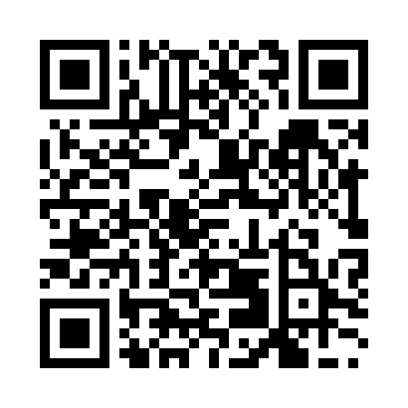
Prayer times for Tokunoshima, Japan
Wed 1 May 2024 - Fri 31 May 2024
High Latitude Method: None
Prayer Calculation Method: Muslim World League
Asar Calculation Method: Shafi

Date | Day | Fajr | Sunrise | Dhuhr | Asr | Maghrib | Isha
1 | Wed | 4:20 | 5:45 | 12:21 | 3:54 | 6:58 | 8:18
2 | Thu | 4:19 | 5:44 | 12:21 | 3:54 | 6:59 | 8:18
3 | Fri | 4:18 | 5:43 | 12:21 | 3:54 | 6:59 | 8:19
4 | Sat | 4:17 | 5:42 | 12:21 | 3:54 | 7:00 | 8:20
5 | Sun | 4:16 | 5:42 | 12:21 | 3:54 | 7:01 | 8:21
6 | Mon | 4:15 | 5:41 | 12:21 | 3:54 | 7:01 | 8:22
7 | Tue | 4:14 | 5:40 | 12:21 | 3:54 | 7:02 | 8:22
8 | Wed | 4:13 | 5:39 | 12:21 | 3:53 | 7:02 | 8:23
9 | Thu | 4:12 | 5:39 | 12:21 | 3:53 | 7:03 | 8:24
10 | Fri | 4:12 | 5:38 | 12:21 | 3:53 | 7:04 | 8:25
11 | Sat | 4:11 | 5:37 | 12:21 | 3:53 | 7:04 | 8:26
12 | Sun | 4:10 | 5:37 | 12:21 | 3:53 | 7:05 | 8:26
13 | Mon | 4:09 | 5:36 | 12:21 | 3:53 | 7:05 | 8:27
14 | Tue | 4:08 | 5:36 | 12:21 | 3:53 | 7:06 | 8:28
15 | Wed | 4:07 | 5:35 | 12:21 | 3:53 | 7:06 | 8:29
16 | Thu | 4:06 | 5:34 | 12:21 | 3:53 | 7:07 | 8:30
17 | Fri | 4:06 | 5:34 | 12:21 | 3:53 | 7:08 | 8:30
18 | Sat | 4:05 | 5:33 | 12:21 | 3:53 | 7:08 | 8:31
19 | Sun | 4:04 | 5:33 | 12:21 | 3:52 | 7:09 | 8:32
20 | Mon | 4:04 | 5:32 | 12:21 | 3:52 | 7:09 | 8:33
21 | Tue | 4:03 | 5:32 | 12:21 | 3:52 | 7:10 | 8:34
22 | Wed | 4:02 | 5:32 | 12:21 | 3:52 | 7:10 | 8:34
23 | Thu | 4:02 | 5:31 | 12:21 | 3:52 | 7:11 | 8:35
24 | Fri | 4:01 | 5:31 | 12:21 | 3:52 | 7:12 | 8:36
25 | Sat | 4:01 | 5:30 | 12:21 | 3:52 | 7:12 | 8:37
26 | Sun | 4:00 | 5:30 | 12:21 | 3:52 | 7:13 | 8:37
27 | Mon | 3:59 | 5:30 | 12:21 | 3:52 | 7:13 | 8:38
28 | Tue | 3:59 | 5:29 | 12:22 | 3:52 | 7:14 | 8:39
29 | Wed | 3:59 | 5:29 | 12:22 | 3:52 | 7:14 | 8:39
30 | Thu | 3:58 | 5:29 | 12:22 | 3:52 | 7:15 | 8:40
31 | Fri | 3:58 | 5:29 | 12:22 | 3:53 | 7:15 | 8:41
Prayer times provided by https://www.salahtimes.com

