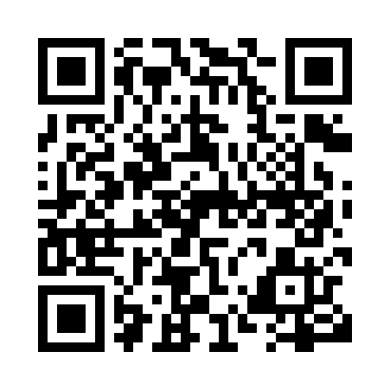
Prayer times for Tour-du-Nord, Quebec, Canada
Wed 1 May 2024 - Fri 31 May 2024
High Latitude Method: Angle Based Rule
Prayer Calculation Method: Islamic Society of North America
Asar Calculation Method: Hanafi

Date | Day | Fajr | Sunrise | Dhuhr | Asr | Maghrib | Isha
1 | Wed | 3:47 | 5:28 | 12:42 | 5:44 | 7:56 | 9:37
2 | Thu | 3:45 | 5:26 | 12:42 | 5:45 | 7:58 | 9:39
3 | Fri | 3:43 | 5:25 | 12:42 | 5:46 | 7:59 | 9:41
4 | Sat | 3:41 | 5:23 | 12:41 | 5:47 | 8:00 | 9:43
5 | Sun | 3:39 | 5:22 | 12:41 | 5:48 | 8:02 | 9:45
6 | Mon | 3:37 | 5:20 | 12:41 | 5:49 | 8:03 | 9:47
7 | Tue | 3:34 | 5:19 | 12:41 | 5:49 | 8:04 | 9:49
8 | Wed | 3:32 | 5:17 | 12:41 | 5:50 | 8:06 | 9:51
9 | Thu | 3:30 | 5:16 | 12:41 | 5:51 | 8:07 | 9:53
10 | Fri | 3:28 | 5:15 | 12:41 | 5:52 | 8:08 | 9:55
11 | Sat | 3:26 | 5:13 | 12:41 | 5:52 | 8:10 | 9:57
12 | Sun | 3:24 | 5:12 | 12:41 | 5:53 | 8:11 | 9:59
13 | Mon | 3:22 | 5:11 | 12:41 | 5:54 | 8:12 | 10:01
14 | Tue | 3:20 | 5:09 | 12:41 | 5:55 | 8:13 | 10:03
15 | Wed | 3:18 | 5:08 | 12:41 | 5:55 | 8:15 | 10:05
16 | Thu | 3:16 | 5:07 | 12:41 | 5:56 | 8:16 | 10:07
17 | Fri | 3:14 | 5:06 | 12:41 | 5:57 | 8:17 | 10:09
18 | Sat | 3:12 | 5:05 | 12:41 | 5:58 | 8:18 | 10:11
19 | Sun | 3:10 | 5:04 | 12:41 | 5:58 | 8:20 | 10:13
20 | Mon | 3:09 | 5:02 | 12:41 | 5:59 | 8:21 | 10:15
21 | Tue | 3:07 | 5:01 | 12:41 | 6:00 | 8:22 | 10:17
22 | Wed | 3:05 | 5:00 | 12:41 | 6:00 | 8:23 | 10:19
23 | Thu | 3:03 | 4:59 | 12:42 | 6:01 | 8:24 | 10:21
24 | Fri | 3:02 | 4:59 | 12:42 | 6:02 | 8:25 | 10:23
25 | Sat | 3:00 | 4:58 | 12:42 | 6:02 | 8:26 | 10:24
26 | Sun | 2:58 | 4:57 | 12:42 | 6:03 | 8:27 | 10:26
27 | Mon | 2:57 | 4:56 | 12:42 | 6:04 | 8:28 | 10:28
28 | Tue | 2:55 | 4:55 | 12:42 | 6:04 | 8:29 | 10:30
29 | Wed | 2:54 | 4:55 | 12:42 | 6:05 | 8:30 | 10:31
30 | Thu | 2:52 | 4:54 | 12:42 | 6:05 | 8:31 | 10:33
31 | Fri | 2:51 | 4:53 | 12:43 | 6:06 | 8:32 | 10:35
Prayer times provided by https://www.salahtimes.com

