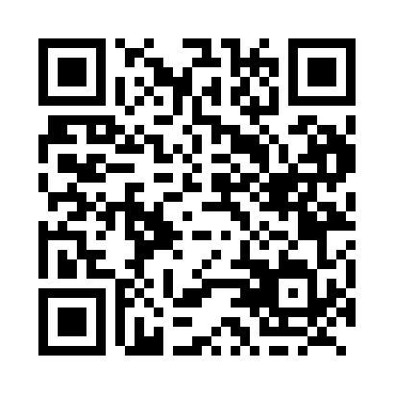
Prayer times for Bromhead, Saskatchewan, Canada
Mon 1 Jul 2024 - Wed 31 Jul 2024
High Latitude Method: Angle Based Rule
Prayer Calculation Method: Islamic Society of North America
Asar Calculation Method: Hanafi

Date | Day | Fajr | Sunrise | Dhuhr | Asr | Maghrib | Isha
1 | Mon | 2:56 | 4:54 | 12:59 | 6:29 | 9:03 | 11:01
2 | Tue | 2:57 | 4:55 | 12:59 | 6:29 | 9:03 | 11:01
3 | Wed | 2:57 | 4:56 | 12:59 | 6:29 | 9:02 | 11:01
4 | Thu | 2:58 | 4:56 | 12:59 | 6:29 | 9:02 | 11:00
5 | Fri | 2:58 | 4:57 | 12:59 | 6:29 | 9:01 | 11:00
6 | Sat | 2:59 | 4:58 | 1:00 | 6:29 | 9:01 | 11:00
7 | Sun | 2:59 | 4:59 | 1:00 | 6:29 | 9:00 | 11:00
8 | Mon | 3:00 | 5:00 | 1:00 | 6:28 | 9:00 | 11:00
9 | Tue | 3:00 | 5:01 | 1:00 | 6:28 | 8:59 | 10:59
10 | Wed | 3:01 | 5:02 | 1:00 | 6:28 | 8:58 | 10:59
11 | Thu | 3:01 | 5:03 | 1:00 | 6:27 | 8:58 | 10:59
12 | Fri | 3:02 | 5:04 | 1:00 | 6:27 | 8:57 | 10:59
13 | Sat | 3:02 | 5:05 | 1:01 | 6:27 | 8:56 | 10:58
14 | Sun | 3:03 | 5:06 | 1:01 | 6:26 | 8:55 | 10:58
15 | Mon | 3:04 | 5:07 | 1:01 | 6:26 | 8:54 | 10:57
16 | Tue | 3:04 | 5:08 | 1:01 | 6:25 | 8:53 | 10:57
17 | Wed | 3:05 | 5:09 | 1:01 | 6:25 | 8:52 | 10:57
18 | Thu | 3:05 | 5:10 | 1:01 | 6:24 | 8:51 | 10:56
19 | Fri | 3:06 | 5:11 | 1:01 | 6:24 | 8:50 | 10:56
20 | Sat | 3:07 | 5:12 | 1:01 | 6:23 | 8:49 | 10:55
21 | Sun | 3:08 | 5:14 | 1:01 | 6:23 | 8:48 | 10:53
22 | Mon | 3:10 | 5:15 | 1:01 | 6:22 | 8:47 | 10:51
23 | Tue | 3:12 | 5:16 | 1:01 | 6:21 | 8:46 | 10:49
24 | Wed | 3:15 | 5:17 | 1:01 | 6:21 | 8:44 | 10:46
25 | Thu | 3:17 | 5:19 | 1:01 | 6:20 | 8:43 | 10:44
26 | Fri | 3:19 | 5:20 | 1:01 | 6:19 | 8:42 | 10:42
27 | Sat | 3:22 | 5:21 | 1:01 | 6:18 | 8:41 | 10:40
28 | Sun | 3:24 | 5:23 | 1:01 | 6:17 | 8:39 | 10:37
29 | Mon | 3:26 | 5:24 | 1:01 | 6:17 | 8:38 | 10:35
30 | Tue | 3:28 | 5:25 | 1:01 | 6:16 | 8:36 | 10:32
31 | Wed | 3:31 | 5:27 | 1:01 | 6:15 | 8:35 | 10:30
Prayer times provided by https://www.salahtimes.com

