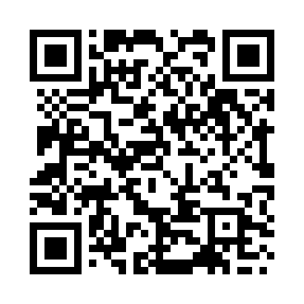
Prayer times for Torkham, Afghanistan
Wed 1 May 2024 - Fri 31 May 2024
High Latitude Method: None
Prayer Calculation Method: University of Islamic Sciences
Asar Calculation Method: Shafi

Date | Day | Fajr | Sunrise | Dhuhr | Asr | Maghrib | Isha
1 | Wed | 3:24 | 4:56 | 11:43 | 3:26 | 6:30 | 8:02
2 | Thu | 3:22 | 4:55 | 11:43 | 3:26 | 6:31 | 8:04
3 | Fri | 3:21 | 4:54 | 11:43 | 3:26 | 6:31 | 8:05
4 | Sat | 3:20 | 4:53 | 11:42 | 3:26 | 6:32 | 8:06
5 | Sun | 3:18 | 4:52 | 11:42 | 3:26 | 6:33 | 8:07
6 | Mon | 3:17 | 4:51 | 11:42 | 3:26 | 6:34 | 8:08
7 | Tue | 3:16 | 4:50 | 11:42 | 3:26 | 6:34 | 8:09
8 | Wed | 3:15 | 4:49 | 11:42 | 3:26 | 6:35 | 8:10
9 | Thu | 3:14 | 4:49 | 11:42 | 3:26 | 6:36 | 8:11
10 | Fri | 3:12 | 4:48 | 11:42 | 3:26 | 6:37 | 8:12
11 | Sat | 3:11 | 4:47 | 11:42 | 3:26 | 6:38 | 8:14
12 | Sun | 3:10 | 4:46 | 11:42 | 3:26 | 6:38 | 8:15
13 | Mon | 3:09 | 4:45 | 11:42 | 3:26 | 6:39 | 8:16
14 | Tue | 3:08 | 4:45 | 11:42 | 3:27 | 6:40 | 8:17
15 | Wed | 3:07 | 4:44 | 11:42 | 3:27 | 6:41 | 8:18
16 | Thu | 3:06 | 4:43 | 11:42 | 3:27 | 6:41 | 8:19
17 | Fri | 3:05 | 4:42 | 11:42 | 3:27 | 6:42 | 8:20
18 | Sat | 3:04 | 4:42 | 11:42 | 3:27 | 6:43 | 8:21
19 | Sun | 3:03 | 4:41 | 11:42 | 3:27 | 6:44 | 8:22
20 | Mon | 3:02 | 4:41 | 11:42 | 3:27 | 6:44 | 8:23
21 | Tue | 3:01 | 4:40 | 11:42 | 3:27 | 6:45 | 8:24
22 | Wed | 3:00 | 4:39 | 11:42 | 3:27 | 6:46 | 8:25
23 | Thu | 2:59 | 4:39 | 11:42 | 3:28 | 6:46 | 8:26
24 | Fri | 2:58 | 4:38 | 11:43 | 3:28 | 6:47 | 8:27
25 | Sat | 2:57 | 4:38 | 11:43 | 3:28 | 6:48 | 8:28
26 | Sun | 2:57 | 4:37 | 11:43 | 3:28 | 6:48 | 8:29
27 | Mon | 2:56 | 4:37 | 11:43 | 3:28 | 6:49 | 8:30
28 | Tue | 2:55 | 4:37 | 11:43 | 3:28 | 6:50 | 8:31
29 | Wed | 2:55 | 4:36 | 11:43 | 3:28 | 6:50 | 8:32
30 | Thu | 2:54 | 4:36 | 11:43 | 3:29 | 6:51 | 8:33
31 | Fri | 2:53 | 4:35 | 11:43 | 3:29 | 6:52 | 8:34
Prayer times provided by https://www.salahtimes.com

