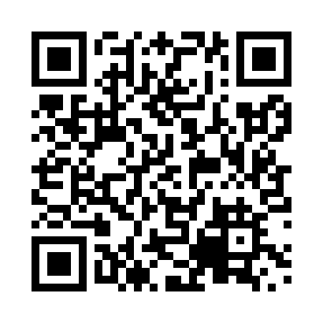
Prayer times for Arbakka, Manitoba, Canada
Wed 1 May 2024 - Fri 31 May 2024
High Latitude Method: Angle Based Rule
Prayer Calculation Method: Islamic Society of North America
Asar Calculation Method: Hanafi

Date | Day | Fajr | Sunrise | Dhuhr | Asr | Maghrib | Isha
1 | Wed | 4:17 | 6:04 | 1:23 | 6:28 | 8:43 | 10:30
2 | Thu | 4:15 | 6:02 | 1:23 | 6:29 | 8:44 | 10:32
3 | Fri | 4:12 | 6:00 | 1:23 | 6:30 | 8:46 | 10:35
4 | Sat | 4:10 | 5:59 | 1:23 | 6:30 | 8:47 | 10:37
5 | Sun | 4:07 | 5:57 | 1:23 | 6:31 | 8:49 | 10:39
6 | Mon | 4:05 | 5:56 | 1:22 | 6:32 | 8:50 | 10:41
7 | Tue | 4:03 | 5:54 | 1:22 | 6:33 | 8:52 | 10:44
8 | Wed | 4:00 | 5:52 | 1:22 | 6:34 | 8:53 | 10:46
9 | Thu | 3:58 | 5:51 | 1:22 | 6:35 | 8:54 | 10:48
10 | Fri | 3:55 | 5:50 | 1:22 | 6:36 | 8:56 | 10:51
11 | Sat | 3:53 | 5:48 | 1:22 | 6:36 | 8:57 | 10:53
12 | Sun | 3:51 | 5:47 | 1:22 | 6:37 | 8:59 | 10:55
13 | Mon | 3:48 | 5:45 | 1:22 | 6:38 | 9:00 | 10:58
14 | Tue | 3:46 | 5:44 | 1:22 | 6:39 | 9:01 | 11:00
15 | Wed | 3:44 | 5:43 | 1:22 | 6:40 | 9:03 | 11:02
16 | Thu | 3:41 | 5:41 | 1:22 | 6:40 | 9:04 | 11:04
17 | Fri | 3:39 | 5:40 | 1:22 | 6:41 | 9:05 | 11:07
18 | Sat | 3:37 | 5:39 | 1:22 | 6:42 | 9:07 | 11:09
19 | Sun | 3:35 | 5:38 | 1:22 | 6:43 | 9:08 | 11:11
20 | Mon | 3:33 | 5:36 | 1:23 | 6:44 | 9:09 | 11:14
21 | Tue | 3:30 | 5:35 | 1:23 | 6:44 | 9:10 | 11:16
22 | Wed | 3:29 | 5:34 | 1:23 | 6:45 | 9:12 | 11:17
23 | Thu | 3:28 | 5:33 | 1:23 | 6:46 | 9:13 | 11:18
24 | Fri | 3:28 | 5:32 | 1:23 | 6:46 | 9:14 | 11:19
25 | Sat | 3:27 | 5:31 | 1:23 | 6:47 | 9:15 | 11:19
26 | Sun | 3:27 | 5:30 | 1:23 | 6:48 | 9:16 | 11:20
27 | Mon | 3:26 | 5:29 | 1:23 | 6:48 | 9:17 | 11:20
28 | Tue | 3:26 | 5:29 | 1:23 | 6:49 | 9:19 | 11:21
29 | Wed | 3:26 | 5:28 | 1:23 | 6:50 | 9:20 | 11:22
30 | Thu | 3:25 | 5:27 | 1:24 | 6:50 | 9:21 | 11:22
31 | Fri | 3:25 | 5:26 | 1:24 | 6:51 | 9:22 | 11:23
Prayer times provided by https://www.salahtimes.com

