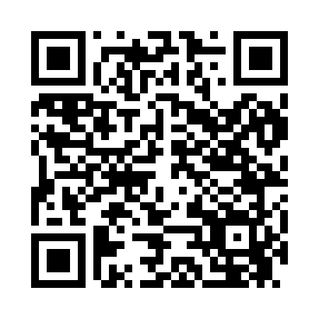
Prayer times for Bonney Lake, Washington, USA
Mon 1 Jul 2024 - Wed 31 Jul 2024
High Latitude Method: Angle Based Rule
Prayer Calculation Method: Islamic Society of North America
Asar Calculation Method: Shafi

Date | Day | Fajr | Sunrise | Dhuhr | Asr | Maghrib | Isha
1 | Mon | 3:15 | 5:17 | 1:13 | 5:26 | 9:08 | 11:10
2 | Tue | 3:15 | 5:18 | 1:13 | 5:26 | 9:08 | 11:10
3 | Wed | 3:16 | 5:19 | 1:13 | 5:26 | 9:07 | 11:10
4 | Thu | 3:16 | 5:19 | 1:13 | 5:26 | 9:07 | 11:10
5 | Fri | 3:17 | 5:20 | 1:14 | 5:26 | 9:07 | 11:10
6 | Sat | 3:17 | 5:21 | 1:14 | 5:26 | 9:06 | 11:10
7 | Sun | 3:18 | 5:22 | 1:14 | 5:26 | 9:06 | 11:10
8 | Mon | 3:19 | 5:23 | 1:14 | 5:26 | 9:05 | 11:09
9 | Tue | 3:20 | 5:23 | 1:14 | 5:26 | 9:05 | 11:08
10 | Wed | 3:22 | 5:24 | 1:14 | 5:26 | 9:04 | 11:06
11 | Thu | 3:23 | 5:25 | 1:14 | 5:26 | 9:03 | 11:05
12 | Fri | 3:25 | 5:26 | 1:15 | 5:26 | 9:03 | 11:03
13 | Sat | 3:26 | 5:27 | 1:15 | 5:25 | 9:02 | 11:02
14 | Sun | 3:28 | 5:28 | 1:15 | 5:25 | 9:01 | 11:01
15 | Mon | 3:30 | 5:29 | 1:15 | 5:25 | 9:00 | 10:59
16 | Tue | 3:32 | 5:30 | 1:15 | 5:25 | 8:59 | 10:57
17 | Wed | 3:33 | 5:31 | 1:15 | 5:25 | 8:58 | 10:56
18 | Thu | 3:35 | 5:32 | 1:15 | 5:24 | 8:58 | 10:54
19 | Fri | 3:37 | 5:33 | 1:15 | 5:24 | 8:57 | 10:52
20 | Sat | 3:39 | 5:34 | 1:15 | 5:24 | 8:56 | 10:51
21 | Sun | 3:41 | 5:35 | 1:15 | 5:23 | 8:54 | 10:49
22 | Mon | 3:43 | 5:37 | 1:15 | 5:23 | 8:53 | 10:47
23 | Tue | 3:44 | 5:38 | 1:15 | 5:23 | 8:52 | 10:45
24 | Wed | 3:46 | 5:39 | 1:15 | 5:22 | 8:51 | 10:43
25 | Thu | 3:48 | 5:40 | 1:15 | 5:22 | 8:50 | 10:41
26 | Fri | 3:50 | 5:41 | 1:15 | 5:22 | 8:49 | 10:39
27 | Sat | 3:52 | 5:42 | 1:15 | 5:21 | 8:48 | 10:37
28 | Sun | 3:54 | 5:44 | 1:15 | 5:21 | 8:46 | 10:35
29 | Mon | 3:56 | 5:45 | 1:15 | 5:20 | 8:45 | 10:33
30 | Tue | 3:58 | 5:46 | 1:15 | 5:20 | 8:44 | 10:31
31 | Wed | 4:00 | 5:47 | 1:15 | 5:19 | 8:42 | 10:29
Prayer times provided by https://www.salahtimes.com

