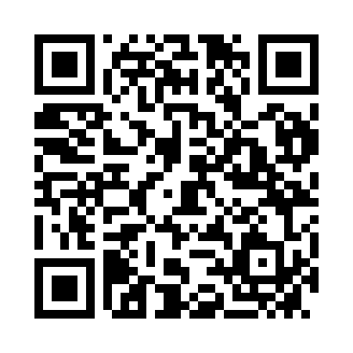
Prayer times for Nenzing, Austria
Wed 1 May 2024 - Fri 31 May 2024
High Latitude Method: Angle Based Rule
Prayer Calculation Method: Muslim World League
Asar Calculation Method: Shafi

Date | Day | Fajr | Sunrise | Dhuhr | Asr | Maghrib | Isha
1 | Wed | 3:59 | 6:05 | 1:18 | 5:17 | 8:33 | 10:30
2 | Thu | 3:56 | 6:03 | 1:18 | 5:17 | 8:34 | 10:32
3 | Fri | 3:54 | 6:01 | 1:18 | 5:18 | 8:35 | 10:35
4 | Sat | 3:51 | 6:00 | 1:18 | 5:18 | 8:37 | 10:37
5 | Sun | 3:49 | 5:58 | 1:18 | 5:19 | 8:38 | 10:39
6 | Mon | 3:46 | 5:57 | 1:18 | 5:19 | 8:39 | 10:41
7 | Tue | 3:44 | 5:55 | 1:18 | 5:20 | 8:41 | 10:43
8 | Wed | 3:41 | 5:54 | 1:18 | 5:20 | 8:42 | 10:46
9 | Thu | 3:39 | 5:53 | 1:18 | 5:21 | 8:43 | 10:48
10 | Fri | 3:36 | 5:51 | 1:18 | 5:21 | 8:45 | 10:50
11 | Sat | 3:34 | 5:50 | 1:18 | 5:22 | 8:46 | 10:52
12 | Sun | 3:31 | 5:49 | 1:18 | 5:22 | 8:47 | 10:55
13 | Mon | 3:29 | 5:47 | 1:18 | 5:23 | 8:48 | 10:57
14 | Tue | 3:26 | 5:46 | 1:18 | 5:23 | 8:50 | 10:59
15 | Wed | 3:24 | 5:45 | 1:18 | 5:24 | 8:51 | 11:02
16 | Thu | 3:21 | 5:44 | 1:18 | 5:24 | 8:52 | 11:04
17 | Fri | 3:19 | 5:42 | 1:18 | 5:24 | 8:53 | 11:06
18 | Sat | 3:17 | 5:41 | 1:18 | 5:25 | 8:55 | 11:08
19 | Sun | 3:14 | 5:40 | 1:18 | 5:25 | 8:56 | 11:11
20 | Mon | 3:12 | 5:39 | 1:18 | 5:26 | 8:57 | 11:13
21 | Tue | 3:10 | 5:38 | 1:18 | 5:26 | 8:58 | 11:15
22 | Wed | 3:07 | 5:37 | 1:18 | 5:27 | 8:59 | 11:17
23 | Thu | 3:05 | 5:36 | 1:18 | 5:27 | 9:00 | 11:20
24 | Fri | 3:03 | 5:35 | 1:18 | 5:28 | 9:02 | 11:22
25 | Sat | 3:01 | 5:34 | 1:18 | 5:28 | 9:03 | 11:24
26 | Sun | 3:00 | 5:33 | 1:18 | 5:28 | 9:04 | 11:26
27 | Mon | 3:00 | 5:33 | 1:18 | 5:29 | 9:05 | 11:28
28 | Tue | 3:00 | 5:32 | 1:19 | 5:29 | 9:06 | 11:29
29 | Wed | 3:00 | 5:31 | 1:19 | 5:30 | 9:07 | 11:30
30 | Thu | 3:00 | 5:30 | 1:19 | 5:30 | 9:08 | 11:30
31 | Fri | 2:59 | 5:30 | 1:19 | 5:30 | 9:09 | 11:31
Prayer times provided by https://www.salahtimes.com

