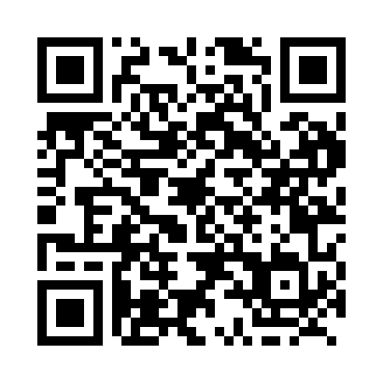
Prayer times for The Gib, Quebec, Canada
Wed 1 May 2024 - Fri 31 May 2024
High Latitude Method: Angle Based Rule
Prayer Calculation Method: Islamic Society of North America
Asar Calculation Method: Hanafi

Date | Day | Fajr | Sunrise | Dhuhr | Asr | Maghrib | Isha
1 | Wed | 2:22 | 4:20 | 11:47 | 4:55 | 7:15 | 9:14
2 | Thu | 2:19 | 4:18 | 11:47 | 4:56 | 7:17 | 9:17
3 | Fri | 2:16 | 4:16 | 11:47 | 4:57 | 7:19 | 9:20
4 | Sat | 2:13 | 4:14 | 11:47 | 4:58 | 7:20 | 9:23
5 | Sun | 2:10 | 4:13 | 11:47 | 4:59 | 7:22 | 9:25
6 | Mon | 2:07 | 4:11 | 11:47 | 5:00 | 7:24 | 9:28
7 | Tue | 2:04 | 4:09 | 11:47 | 5:01 | 7:25 | 9:31
8 | Wed | 2:01 | 4:07 | 11:47 | 5:02 | 7:27 | 9:34
9 | Thu | 1:58 | 4:06 | 11:47 | 5:03 | 7:28 | 9:37
10 | Fri | 1:56 | 4:04 | 11:47 | 5:04 | 7:30 | 9:39
11 | Sat | 1:55 | 4:02 | 11:47 | 5:05 | 7:32 | 9:39
12 | Sun | 1:54 | 4:01 | 11:47 | 5:06 | 7:33 | 9:40
13 | Mon | 1:53 | 3:59 | 11:47 | 5:07 | 7:35 | 9:41
14 | Tue | 1:52 | 3:58 | 11:47 | 5:08 | 7:36 | 9:42
15 | Wed | 1:52 | 3:56 | 11:47 | 5:08 | 7:38 | 9:42
16 | Thu | 1:51 | 3:55 | 11:47 | 5:09 | 7:39 | 9:43
17 | Fri | 1:50 | 3:53 | 11:47 | 5:10 | 7:41 | 9:44
18 | Sat | 1:49 | 3:52 | 11:47 | 5:11 | 7:42 | 9:45
19 | Sun | 1:49 | 3:51 | 11:47 | 5:12 | 7:44 | 9:45
20 | Mon | 1:48 | 3:49 | 11:47 | 5:13 | 7:45 | 9:46
21 | Tue | 1:48 | 3:48 | 11:47 | 5:14 | 7:46 | 9:47
22 | Wed | 1:47 | 3:47 | 11:47 | 5:14 | 7:48 | 9:48
23 | Thu | 1:46 | 3:46 | 11:47 | 5:15 | 7:49 | 9:48
24 | Fri | 1:46 | 3:44 | 11:47 | 5:16 | 7:51 | 9:49
25 | Sat | 1:45 | 3:43 | 11:47 | 5:17 | 7:52 | 9:50
26 | Sun | 1:45 | 3:42 | 11:47 | 5:17 | 7:53 | 9:50
27 | Mon | 1:44 | 3:41 | 11:47 | 5:18 | 7:54 | 9:51
28 | Tue | 1:44 | 3:40 | 11:48 | 5:19 | 7:56 | 9:52
29 | Wed | 1:44 | 3:39 | 11:48 | 5:20 | 7:57 | 9:52
30 | Thu | 1:43 | 3:38 | 11:48 | 5:20 | 7:58 | 9:53
31 | Fri | 1:43 | 3:37 | 11:48 | 5:21 | 7:59 | 9:54
Prayer times provided by https://www.salahtimes.com

