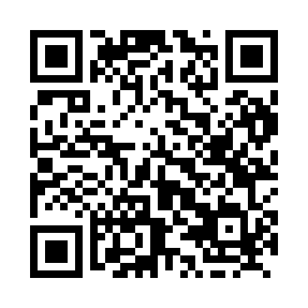
Prayer times for Brikama Ba, Gambia
Wed 1 May 2024 - Fri 31 May 2024
High Latitude Method: None
Prayer Calculation Method: Muslim World League
Asar Calculation Method: Shafi

Date | Day | Fajr | Sunrise | Dhuhr | Asr | Maghrib | Isha
1 | Wed | 5:24 | 6:38 | 12:57 | 4:07 | 7:16 | 8:26
2 | Thu | 5:23 | 6:38 | 12:57 | 4:07 | 7:16 | 8:26
3 | Fri | 5:23 | 6:37 | 12:57 | 4:08 | 7:16 | 8:26
4 | Sat | 5:22 | 6:37 | 12:56 | 4:08 | 7:16 | 8:27
5 | Sun | 5:22 | 6:37 | 12:56 | 4:09 | 7:16 | 8:27
6 | Mon | 5:21 | 6:36 | 12:56 | 4:09 | 7:17 | 8:27
7 | Tue | 5:21 | 6:36 | 12:56 | 4:10 | 7:17 | 8:28
8 | Wed | 5:20 | 6:36 | 12:56 | 4:10 | 7:17 | 8:28
9 | Thu | 5:20 | 6:35 | 12:56 | 4:11 | 7:17 | 8:28
10 | Fri | 5:19 | 6:35 | 12:56 | 4:11 | 7:18 | 8:29
11 | Sat | 5:19 | 6:35 | 12:56 | 4:12 | 7:18 | 8:29
12 | Sun | 5:18 | 6:34 | 12:56 | 4:12 | 7:18 | 8:30
13 | Mon | 5:18 | 6:34 | 12:56 | 4:13 | 7:18 | 8:30
14 | Tue | 5:17 | 6:34 | 12:56 | 4:13 | 7:19 | 8:30
15 | Wed | 5:17 | 6:33 | 12:56 | 4:14 | 7:19 | 8:31
16 | Thu | 5:17 | 6:33 | 12:56 | 4:14 | 7:19 | 8:31
17 | Fri | 5:16 | 6:33 | 12:56 | 4:15 | 7:19 | 8:32
18 | Sat | 5:16 | 6:33 | 12:56 | 4:15 | 7:20 | 8:32
19 | Sun | 5:16 | 6:33 | 12:56 | 4:16 | 7:20 | 8:32
20 | Mon | 5:15 | 6:32 | 12:56 | 4:16 | 7:20 | 8:33
21 | Tue | 5:15 | 6:32 | 12:56 | 4:17 | 7:21 | 8:33
22 | Wed | 5:15 | 6:32 | 12:56 | 4:17 | 7:21 | 8:34
23 | Thu | 5:15 | 6:32 | 12:57 | 4:18 | 7:21 | 8:34
24 | Fri | 5:14 | 6:32 | 12:57 | 4:18 | 7:21 | 8:35
25 | Sat | 5:14 | 6:32 | 12:57 | 4:19 | 7:22 | 8:35
26 | Sun | 5:14 | 6:32 | 12:57 | 4:19 | 7:22 | 8:35
27 | Mon | 5:14 | 6:32 | 12:57 | 4:19 | 7:22 | 8:36
28 | Tue | 5:14 | 6:32 | 12:57 | 4:20 | 7:23 | 8:36
29 | Wed | 5:13 | 6:32 | 12:57 | 4:20 | 7:23 | 8:37
30 | Thu | 5:13 | 6:32 | 12:57 | 4:21 | 7:23 | 8:37
31 | Fri | 5:13 | 6:31 | 12:58 | 4:21 | 7:24 | 8:37
Prayer times provided by https://www.salahtimes.com

