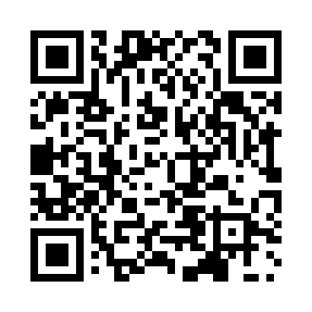
Prayer times for Gelbressee, Belgium
Mon 1 Apr 2024 - Tue 30 Apr 2024
High Latitude Method: Angle Based Rule
Prayer Calculation Method: Muslim World League
Asar Calculation Method: Shafi

Date | Day | Fajr | Sunrise | Dhuhr | Asr | Maghrib | Isha
1 | Mon | 5:20 | 7:16 | 1:44 | 5:17 | 8:13 | 10:02
2 | Tue | 5:17 | 7:13 | 1:44 | 5:18 | 8:15 | 10:04
3 | Wed | 5:15 | 7:11 | 1:43 | 5:19 | 8:16 | 10:06
4 | Thu | 5:12 | 7:09 | 1:43 | 5:20 | 8:18 | 10:08
5 | Fri | 5:09 | 7:07 | 1:43 | 5:21 | 8:20 | 10:10
6 | Sat | 5:06 | 7:05 | 1:42 | 5:22 | 8:21 | 10:12
7 | Sun | 5:03 | 7:03 | 1:42 | 5:22 | 8:23 | 10:14
8 | Mon | 5:01 | 7:00 | 1:42 | 5:23 | 8:24 | 10:17
9 | Tue | 4:58 | 6:58 | 1:42 | 5:24 | 8:26 | 10:19
10 | Wed | 4:55 | 6:56 | 1:41 | 5:25 | 8:28 | 10:21
11 | Thu | 4:52 | 6:54 | 1:41 | 5:25 | 8:29 | 10:23
12 | Fri | 4:49 | 6:52 | 1:41 | 5:26 | 8:31 | 10:26
13 | Sat | 4:46 | 6:50 | 1:41 | 5:27 | 8:32 | 10:28
14 | Sun | 4:44 | 6:48 | 1:40 | 5:28 | 8:34 | 10:30
15 | Mon | 4:41 | 6:46 | 1:40 | 5:28 | 8:36 | 10:33
16 | Tue | 4:38 | 6:43 | 1:40 | 5:29 | 8:37 | 10:35
17 | Wed | 4:35 | 6:41 | 1:40 | 5:30 | 8:39 | 10:37
18 | Thu | 4:32 | 6:39 | 1:39 | 5:31 | 8:40 | 10:40
19 | Fri | 4:29 | 6:37 | 1:39 | 5:31 | 8:42 | 10:42
20 | Sat | 4:26 | 6:35 | 1:39 | 5:32 | 8:44 | 10:45
21 | Sun | 4:23 | 6:33 | 1:39 | 5:33 | 8:45 | 10:47
22 | Mon | 4:20 | 6:31 | 1:39 | 5:33 | 8:47 | 10:50
23 | Tue | 4:17 | 6:29 | 1:38 | 5:34 | 8:48 | 10:52
24 | Wed | 4:14 | 6:27 | 1:38 | 5:35 | 8:50 | 10:55
25 | Thu | 4:10 | 6:25 | 1:38 | 5:35 | 8:52 | 10:58
26 | Fri | 4:07 | 6:24 | 1:38 | 5:36 | 8:53 | 11:00
27 | Sat | 4:04 | 6:22 | 1:38 | 5:37 | 8:55 | 11:03
28 | Sun | 4:01 | 6:20 | 1:38 | 5:37 | 8:56 | 11:06
29 | Mon | 3:58 | 6:18 | 1:37 | 5:38 | 8:58 | 11:08
30 | Tue | 3:55 | 6:16 | 1:37 | 5:39 | 8:59 | 11:11
Prayer times provided by https://www.salahtimes.com

