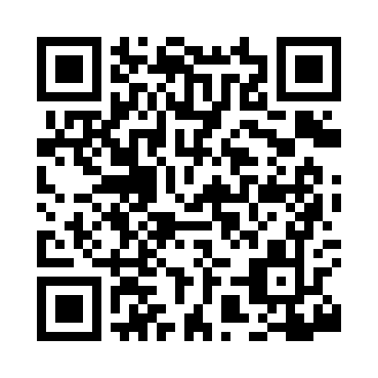
Prayer times for Nagos, Montana, USA
Mon 1 Jul 2024 - Wed 31 Jul 2024
High Latitude Method: Angle Based Rule
Prayer Calculation Method: Islamic Society of North America
Asar Calculation Method: Shafi

Date | Day | Fajr | Sunrise | Dhuhr | Asr | Maghrib | Isha
1 | Mon | 3:43 | 5:46 | 1:41 | 5:53 | 9:35 | 11:38
2 | Tue | 3:44 | 5:47 | 1:41 | 5:53 | 9:35 | 11:38
3 | Wed | 3:44 | 5:47 | 1:41 | 5:53 | 9:34 | 11:38
4 | Thu | 3:44 | 5:48 | 1:41 | 5:53 | 9:34 | 11:37
5 | Fri | 3:45 | 5:49 | 1:41 | 5:53 | 9:34 | 11:37
6 | Sat | 3:45 | 5:49 | 1:41 | 5:53 | 9:33 | 11:37
7 | Sun | 3:47 | 5:50 | 1:42 | 5:53 | 9:33 | 11:36
8 | Mon | 3:48 | 5:51 | 1:42 | 5:53 | 9:32 | 11:35
9 | Tue | 3:50 | 5:52 | 1:42 | 5:53 | 9:31 | 11:33
10 | Wed | 3:51 | 5:53 | 1:42 | 5:53 | 9:31 | 11:32
11 | Thu | 3:53 | 5:54 | 1:42 | 5:53 | 9:30 | 11:31
12 | Fri | 3:54 | 5:55 | 1:42 | 5:53 | 9:30 | 11:29
13 | Sat | 3:56 | 5:55 | 1:42 | 5:53 | 9:29 | 11:28
14 | Sun | 3:57 | 5:56 | 1:42 | 5:53 | 9:28 | 11:27
15 | Mon | 3:59 | 5:57 | 1:43 | 5:52 | 9:27 | 11:25
16 | Tue | 4:01 | 5:58 | 1:43 | 5:52 | 9:26 | 11:23
17 | Wed | 4:03 | 5:59 | 1:43 | 5:52 | 9:25 | 11:22
18 | Thu | 4:04 | 6:01 | 1:43 | 5:52 | 9:25 | 11:20
19 | Fri | 4:06 | 6:02 | 1:43 | 5:51 | 9:24 | 11:18
20 | Sat | 4:08 | 6:03 | 1:43 | 5:51 | 9:23 | 11:17
21 | Sun | 4:10 | 6:04 | 1:43 | 5:51 | 9:22 | 11:15
22 | Mon | 4:12 | 6:05 | 1:43 | 5:51 | 9:20 | 11:13
23 | Tue | 4:14 | 6:06 | 1:43 | 5:50 | 9:19 | 11:11
24 | Wed | 4:16 | 6:07 | 1:43 | 5:50 | 9:18 | 11:09
25 | Thu | 4:17 | 6:08 | 1:43 | 5:49 | 9:17 | 11:08
26 | Fri | 4:19 | 6:10 | 1:43 | 5:49 | 9:16 | 11:06
27 | Sat | 4:21 | 6:11 | 1:43 | 5:49 | 9:15 | 11:04
28 | Sun | 4:23 | 6:12 | 1:43 | 5:48 | 9:13 | 11:02
29 | Mon | 4:25 | 6:13 | 1:43 | 5:48 | 9:12 | 11:00
30 | Tue | 4:27 | 6:14 | 1:43 | 5:47 | 9:11 | 10:58
31 | Wed | 4:29 | 6:16 | 1:43 | 5:47 | 9:09 | 10:56
Prayer times provided by https://www.salahtimes.com

