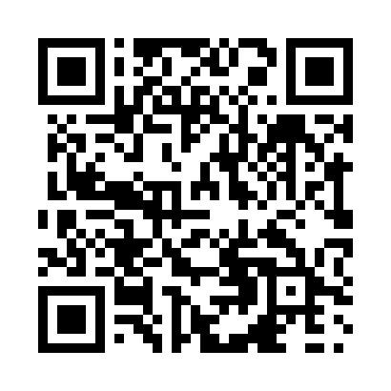
Prayer times for Groves Point, Nova Scotia, Canada
Wed 1 May 2024 - Fri 31 May 2024
High Latitude Method: Angle Based Rule
Prayer Calculation Method: Islamic Society of North America
Asar Calculation Method: Hanafi

Date | Day | Fajr | Sunrise | Dhuhr | Asr | Maghrib | Isha
1 | Wed | 4:09 | 5:47 | 12:58 | 6:00 | 8:11 | 9:49
2 | Thu | 4:07 | 5:45 | 12:58 | 6:01 | 8:12 | 9:50
3 | Fri | 4:05 | 5:44 | 12:58 | 6:02 | 8:13 | 9:52
4 | Sat | 4:03 | 5:42 | 12:58 | 6:02 | 8:14 | 9:54
5 | Sun | 4:01 | 5:41 | 12:58 | 6:03 | 8:16 | 9:56
6 | Mon | 3:59 | 5:39 | 12:58 | 6:04 | 8:17 | 9:58
7 | Tue | 3:57 | 5:38 | 12:58 | 6:05 | 8:18 | 10:00
8 | Wed | 3:55 | 5:37 | 12:58 | 6:05 | 8:20 | 10:02
9 | Thu | 3:53 | 5:35 | 12:58 | 6:06 | 8:21 | 10:04
10 | Fri | 3:51 | 5:34 | 12:58 | 6:07 | 8:22 | 10:06
11 | Sat | 3:49 | 5:33 | 12:58 | 6:08 | 8:23 | 10:08
12 | Sun | 3:47 | 5:31 | 12:58 | 6:08 | 8:25 | 10:09
13 | Mon | 3:45 | 5:30 | 12:58 | 6:09 | 8:26 | 10:11
14 | Tue | 3:43 | 5:29 | 12:58 | 6:10 | 8:27 | 10:13
15 | Wed | 3:41 | 5:28 | 12:58 | 6:11 | 8:28 | 10:15
16 | Thu | 3:40 | 5:27 | 12:58 | 6:11 | 8:29 | 10:17
17 | Fri | 3:38 | 5:26 | 12:58 | 6:12 | 8:31 | 10:19
18 | Sat | 3:36 | 5:24 | 12:58 | 6:13 | 8:32 | 10:21
19 | Sun | 3:34 | 5:23 | 12:58 | 6:13 | 8:33 | 10:22
20 | Mon | 3:33 | 5:22 | 12:58 | 6:14 | 8:34 | 10:24
21 | Tue | 3:31 | 5:21 | 12:58 | 6:15 | 8:35 | 10:26
22 | Wed | 3:29 | 5:20 | 12:58 | 6:15 | 8:36 | 10:28
23 | Thu | 3:28 | 5:20 | 12:58 | 6:16 | 8:37 | 10:30
24 | Fri | 3:26 | 5:19 | 12:58 | 6:17 | 8:38 | 10:31
25 | Sat | 3:25 | 5:18 | 12:58 | 6:17 | 8:39 | 10:33
26 | Sun | 3:23 | 5:17 | 12:58 | 6:18 | 8:40 | 10:35
27 | Mon | 3:22 | 5:16 | 12:59 | 6:18 | 8:41 | 10:36
28 | Tue | 3:20 | 5:15 | 12:59 | 6:19 | 8:42 | 10:38
29 | Wed | 3:19 | 5:15 | 12:59 | 6:20 | 8:43 | 10:39
30 | Thu | 3:18 | 5:14 | 12:59 | 6:20 | 8:44 | 10:41
31 | Fri | 3:17 | 5:14 | 12:59 | 6:21 | 8:45 | 10:42
Prayer times provided by https://www.salahtimes.com

