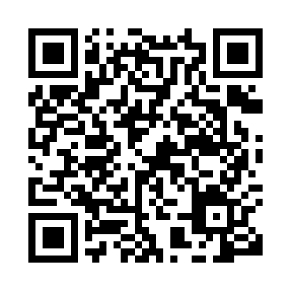
Prayer times for Abi, Congo
Wed 1 May 2024 - Fri 31 May 2024
High Latitude Method: None
Prayer Calculation Method: Muslim World League
Asar Calculation Method: Shafi

Date | Day | Fajr | Sunrise | Dhuhr | Asr | Maghrib | Isha
1 | Wed | 4:44 | 5:55 | 11:56 | 3:17 | 5:56 | 7:03
2 | Thu | 4:43 | 5:55 | 11:55 | 3:17 | 5:56 | 7:03
3 | Fri | 4:43 | 5:55 | 11:55 | 3:17 | 5:56 | 7:03
4 | Sat | 4:43 | 5:55 | 11:55 | 3:17 | 5:56 | 7:03
5 | Sun | 4:43 | 5:54 | 11:55 | 3:17 | 5:56 | 7:03
6 | Mon | 4:43 | 5:54 | 11:55 | 3:17 | 5:56 | 7:03
7 | Tue | 4:43 | 5:54 | 11:55 | 3:17 | 5:56 | 7:03
8 | Wed | 4:43 | 5:54 | 11:55 | 3:17 | 5:56 | 7:03
9 | Thu | 4:42 | 5:54 | 11:55 | 3:17 | 5:55 | 7:03
10 | Fri | 4:42 | 5:54 | 11:55 | 3:18 | 5:55 | 7:03
11 | Sat | 4:42 | 5:54 | 11:55 | 3:18 | 5:55 | 7:03
12 | Sun | 4:42 | 5:54 | 11:55 | 3:18 | 5:55 | 7:03
13 | Mon | 4:42 | 5:54 | 11:55 | 3:18 | 5:55 | 7:03
14 | Tue | 4:42 | 5:55 | 11:55 | 3:18 | 5:55 | 7:04
15 | Wed | 4:42 | 5:55 | 11:55 | 3:18 | 5:55 | 7:04
16 | Thu | 4:42 | 5:55 | 11:55 | 3:18 | 5:55 | 7:04
17 | Fri | 4:42 | 5:55 | 11:55 | 3:18 | 5:55 | 7:04
18 | Sat | 4:42 | 5:55 | 11:55 | 3:18 | 5:55 | 7:04
19 | Sun | 4:42 | 5:55 | 11:55 | 3:19 | 5:55 | 7:04
20 | Mon | 4:42 | 5:55 | 11:55 | 3:19 | 5:55 | 7:04
21 | Tue | 4:42 | 5:55 | 11:55 | 3:19 | 5:55 | 7:04
22 | Wed | 4:42 | 5:55 | 11:55 | 3:19 | 5:55 | 7:04
23 | Thu | 4:42 | 5:55 | 11:55 | 3:19 | 5:55 | 7:05
24 | Fri | 4:42 | 5:55 | 11:55 | 3:19 | 5:55 | 7:05
25 | Sat | 4:42 | 5:56 | 11:55 | 3:19 | 5:55 | 7:05
26 | Sun | 4:42 | 5:56 | 11:56 | 3:20 | 5:56 | 7:05
27 | Mon | 4:42 | 5:56 | 11:56 | 3:20 | 5:56 | 7:05
28 | Tue | 4:42 | 5:56 | 11:56 | 3:20 | 5:56 | 7:05
29 | Wed | 4:42 | 5:56 | 11:56 | 3:20 | 5:56 | 7:06
30 | Thu | 4:42 | 5:56 | 11:56 | 3:20 | 5:56 | 7:06
31 | Fri | 4:42 | 5:56 | 11:56 | 3:20 | 5:56 | 7:06
Prayer times provided by https://www.salahtimes.com

