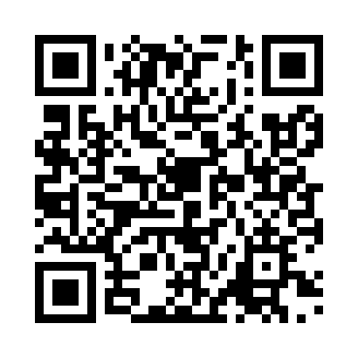
Prayer times for Tarama, Japan
Wed 1 May 2024 - Fri 31 May 2024
High Latitude Method: None
Prayer Calculation Method: Muslim World League
Asar Calculation Method: Shafi

Date | Day | Fajr | Sunrise | Dhuhr | Asr | Maghrib | Isha
1 | Wed | 4:45 | 6:06 | 12:38 | 4:06 | 7:11 | 8:28
2 | Thu | 4:44 | 6:05 | 12:38 | 4:06 | 7:11 | 8:28
3 | Fri | 4:43 | 6:05 | 12:38 | 4:05 | 7:12 | 8:29
4 | Sat | 4:42 | 6:04 | 12:38 | 4:05 | 7:12 | 8:30
5 | Sun | 4:41 | 6:03 | 12:38 | 4:05 | 7:13 | 8:30
6 | Mon | 4:40 | 6:03 | 12:38 | 4:05 | 7:13 | 8:31
7 | Tue | 4:39 | 6:02 | 12:38 | 4:04 | 7:14 | 8:32
8 | Wed | 4:39 | 6:01 | 12:38 | 4:04 | 7:14 | 8:32
9 | Thu | 4:38 | 6:01 | 12:38 | 4:04 | 7:15 | 8:33
10 | Fri | 4:37 | 6:00 | 12:38 | 4:04 | 7:15 | 8:34
11 | Sat | 4:36 | 6:00 | 12:38 | 4:04 | 7:16 | 8:34
12 | Sun | 4:35 | 5:59 | 12:38 | 4:03 | 7:16 | 8:35
13 | Mon | 4:35 | 5:59 | 12:38 | 4:03 | 7:17 | 8:36
14 | Tue | 4:34 | 5:58 | 12:38 | 4:03 | 7:17 | 8:37
15 | Wed | 4:33 | 5:58 | 12:38 | 4:03 | 7:18 | 8:37
16 | Thu | 4:33 | 5:57 | 12:38 | 4:03 | 7:19 | 8:38
17 | Fri | 4:32 | 5:57 | 12:38 | 4:03 | 7:19 | 8:39
18 | Sat | 4:31 | 5:56 | 12:38 | 4:02 | 7:20 | 8:39
19 | Sun | 4:31 | 5:56 | 12:38 | 4:02 | 7:20 | 8:40
20 | Mon | 4:30 | 5:55 | 12:38 | 4:02 | 7:21 | 8:41
21 | Tue | 4:30 | 5:55 | 12:38 | 4:02 | 7:21 | 8:41
22 | Wed | 4:29 | 5:55 | 12:38 | 4:02 | 7:22 | 8:42
23 | Thu | 4:28 | 5:54 | 12:38 | 4:02 | 7:22 | 8:43
24 | Fri | 4:28 | 5:54 | 12:38 | 4:02 | 7:23 | 8:43
25 | Sat | 4:27 | 5:54 | 12:38 | 4:02 | 7:23 | 8:44
26 | Sun | 4:27 | 5:53 | 12:38 | 4:02 | 7:23 | 8:45
27 | Mon | 4:27 | 5:53 | 12:38 | 4:02 | 7:24 | 8:45
28 | Tue | 4:26 | 5:53 | 12:39 | 4:02 | 7:24 | 8:46
29 | Wed | 4:26 | 5:53 | 12:39 | 4:02 | 7:25 | 8:47
30 | Thu | 4:25 | 5:53 | 12:39 | 4:01 | 7:25 | 8:47
31 | Fri | 4:25 | 5:52 | 12:39 | 4:01 | 7:26 | 8:48
Prayer times provided by https://www.salahtimes.com

