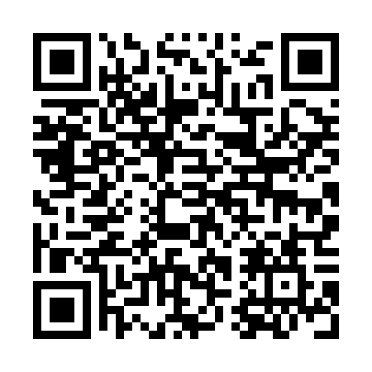
Prayer times for Tarin Kowt, Afghanistan
Mon 1 Apr 2024 - Tue 30 Apr 2024
High Latitude Method: None
Prayer Calculation Method: University of Islamic Sciences
Asar Calculation Method: Shafi

Date | Day | Fajr | Sunrise | Dhuhr | Asr | Maghrib | Isha
1 | Mon | 4:31 | 5:54 | 12:10 | 3:43 | 6:27 | 7:50
2 | Tue | 4:30 | 5:53 | 12:10 | 3:43 | 6:27 | 7:51
3 | Wed | 4:28 | 5:52 | 12:10 | 3:43 | 6:28 | 7:52
4 | Thu | 4:27 | 5:51 | 12:09 | 3:43 | 6:29 | 7:53
5 | Fri | 4:25 | 5:49 | 12:09 | 3:44 | 6:30 | 7:54
6 | Sat | 4:24 | 5:48 | 12:09 | 3:44 | 6:30 | 7:55
7 | Sun | 4:22 | 5:47 | 12:09 | 3:44 | 6:31 | 7:55
8 | Mon | 4:21 | 5:45 | 12:08 | 3:44 | 6:32 | 7:56
9 | Tue | 4:19 | 5:44 | 12:08 | 3:44 | 6:32 | 7:57
10 | Wed | 4:18 | 5:43 | 12:08 | 3:44 | 6:33 | 7:58
11 | Thu | 4:17 | 5:42 | 12:08 | 3:44 | 6:34 | 7:59
12 | Fri | 4:15 | 5:41 | 12:07 | 3:44 | 6:34 | 8:00
13 | Sat | 4:14 | 5:39 | 12:07 | 3:44 | 6:35 | 8:01
14 | Sun | 4:12 | 5:38 | 12:07 | 3:44 | 6:36 | 8:02
15 | Mon | 4:11 | 5:37 | 12:07 | 3:44 | 6:37 | 8:03
16 | Tue | 4:09 | 5:36 | 12:06 | 3:44 | 6:37 | 8:04
17 | Wed | 4:08 | 5:35 | 12:06 | 3:44 | 6:38 | 8:05
18 | Thu | 4:07 | 5:33 | 12:06 | 3:44 | 6:39 | 8:06
19 | Fri | 4:05 | 5:32 | 12:06 | 3:44 | 6:39 | 8:07
20 | Sat | 4:04 | 5:31 | 12:05 | 3:44 | 6:40 | 8:08
21 | Sun | 4:02 | 5:30 | 12:05 | 3:44 | 6:41 | 8:09
22 | Mon | 4:01 | 5:29 | 12:05 | 3:44 | 6:42 | 8:10
23 | Tue | 4:00 | 5:28 | 12:05 | 3:44 | 6:42 | 8:11
24 | Wed | 3:58 | 5:27 | 12:05 | 3:44 | 6:43 | 8:12
25 | Thu | 3:57 | 5:26 | 12:04 | 3:44 | 6:44 | 8:13
26 | Fri | 3:56 | 5:25 | 12:04 | 3:44 | 6:45 | 8:14
27 | Sat | 3:54 | 5:23 | 12:04 | 3:44 | 6:45 | 8:15
28 | Sun | 3:53 | 5:22 | 12:04 | 3:44 | 6:46 | 8:16
29 | Mon | 3:52 | 5:21 | 12:04 | 3:44 | 6:47 | 8:17
30 | Tue | 3:50 | 5:20 | 12:04 | 3:44 | 6:47 | 8:18
Prayer times provided by https://www.salahtimes.com

