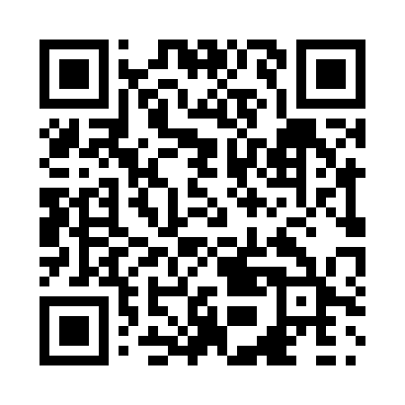
Prayer times for Bonnet Hill, British Columbia, Canada
Mon 1 Apr 2024 - Tue 30 Apr 2024
High Latitude Method: Angle Based Rule
Prayer Calculation Method: Islamic Society of North America
Asar Calculation Method: Hanafi

Date | Day | Fajr | Sunrise | Dhuhr | Asr | Maghrib | Isha
1 | Mon | 4:59 | 6:42 | 1:14 | 5:41 | 7:48 | 9:31
2 | Tue | 4:56 | 6:39 | 1:14 | 5:42 | 7:50 | 9:33
3 | Wed | 4:53 | 6:37 | 1:14 | 5:43 | 7:51 | 9:36
4 | Thu | 4:50 | 6:34 | 1:13 | 5:45 | 7:53 | 9:38
5 | Fri | 4:47 | 6:32 | 1:13 | 5:46 | 7:55 | 9:41
6 | Sat | 4:44 | 6:29 | 1:13 | 5:47 | 7:57 | 9:43
7 | Sun | 4:41 | 6:27 | 1:12 | 5:49 | 7:59 | 9:45
8 | Mon | 4:38 | 6:25 | 1:12 | 5:50 | 8:01 | 9:48
9 | Tue | 4:35 | 6:22 | 1:12 | 5:51 | 8:03 | 9:50
10 | Wed | 4:32 | 6:20 | 1:12 | 5:53 | 8:04 | 9:53
11 | Thu | 4:29 | 6:17 | 1:11 | 5:54 | 8:06 | 9:56
12 | Fri | 4:25 | 6:15 | 1:11 | 5:55 | 8:08 | 9:58
13 | Sat | 4:22 | 6:13 | 1:11 | 5:56 | 8:10 | 10:01
14 | Sun | 4:19 | 6:10 | 1:11 | 5:58 | 8:12 | 10:04
15 | Mon | 4:16 | 6:08 | 1:10 | 5:59 | 8:14 | 10:06
16 | Tue | 4:13 | 6:06 | 1:10 | 6:00 | 8:16 | 10:09
17 | Wed | 4:10 | 6:03 | 1:10 | 6:01 | 8:17 | 10:12
18 | Thu | 4:06 | 6:01 | 1:10 | 6:03 | 8:19 | 10:14
19 | Fri | 4:03 | 5:59 | 1:09 | 6:04 | 8:21 | 10:17
20 | Sat | 4:00 | 5:57 | 1:09 | 6:05 | 8:23 | 10:20
21 | Sun | 3:57 | 5:54 | 1:09 | 6:06 | 8:25 | 10:23
22 | Mon | 3:53 | 5:52 | 1:09 | 6:07 | 8:27 | 10:26
23 | Tue | 3:50 | 5:50 | 1:09 | 6:09 | 8:28 | 10:29
24 | Wed | 3:47 | 5:48 | 1:08 | 6:10 | 8:30 | 10:32
25 | Thu | 3:43 | 5:45 | 1:08 | 6:11 | 8:32 | 10:35
26 | Fri | 3:40 | 5:43 | 1:08 | 6:12 | 8:34 | 10:38
27 | Sat | 3:37 | 5:41 | 1:08 | 6:13 | 8:36 | 10:41
28 | Sun | 3:33 | 5:39 | 1:08 | 6:14 | 8:38 | 10:44
29 | Mon | 3:30 | 5:37 | 1:08 | 6:16 | 8:40 | 10:48
30 | Tue | 3:26 | 5:35 | 1:08 | 6:17 | 8:41 | 10:51
Prayer times provided by https://www.salahtimes.com

