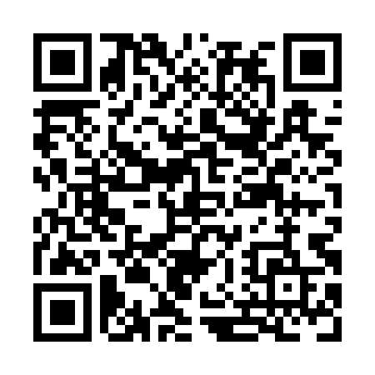
Prayer times for Shawnigan Lake, British Columbia, Canada
Mon 1 Jul 2024 - Wed 31 Jul 2024
High Latitude Method: Angle Based Rule
Prayer Calculation Method: Islamic Society of North America
Asar Calculation Method: Hanafi

Date | Day | Fajr | Sunrise | Dhuhr | Asr | Maghrib | Isha
1 | Mon | 3:18 | 5:17 | 1:19 | 6:48 | 9:20 | 11:19
2 | Tue | 3:18 | 5:17 | 1:19 | 6:48 | 9:20 | 11:19
3 | Wed | 3:18 | 5:18 | 1:19 | 6:48 | 9:20 | 11:19
4 | Thu | 3:19 | 5:19 | 1:19 | 6:48 | 9:19 | 11:19
5 | Fri | 3:19 | 5:19 | 1:19 | 6:48 | 9:19 | 11:19
6 | Sat | 3:20 | 5:20 | 1:19 | 6:48 | 9:18 | 11:19
7 | Sun | 3:20 | 5:21 | 1:20 | 6:47 | 9:18 | 11:19
8 | Mon | 3:21 | 5:22 | 1:20 | 6:47 | 9:17 | 11:18
9 | Tue | 3:21 | 5:23 | 1:20 | 6:47 | 9:17 | 11:18
10 | Wed | 3:22 | 5:24 | 1:20 | 6:47 | 9:16 | 11:18
11 | Thu | 3:22 | 5:25 | 1:20 | 6:46 | 9:15 | 11:18
12 | Fri | 3:23 | 5:26 | 1:20 | 6:46 | 9:14 | 11:17
13 | Sat | 3:23 | 5:27 | 1:20 | 6:45 | 9:14 | 11:17
14 | Sun | 3:24 | 5:28 | 1:21 | 6:45 | 9:13 | 11:17
15 | Mon | 3:25 | 5:29 | 1:21 | 6:45 | 9:12 | 11:16
16 | Tue | 3:25 | 5:30 | 1:21 | 6:44 | 9:11 | 11:16
17 | Wed | 3:26 | 5:31 | 1:21 | 6:44 | 9:10 | 11:15
18 | Thu | 3:27 | 5:32 | 1:21 | 6:43 | 9:09 | 11:14
19 | Fri | 3:29 | 5:33 | 1:21 | 6:43 | 9:08 | 11:12
20 | Sat | 3:31 | 5:34 | 1:21 | 6:42 | 9:07 | 11:10
21 | Sun | 3:33 | 5:36 | 1:21 | 6:41 | 9:06 | 11:08
22 | Mon | 3:35 | 5:37 | 1:21 | 6:41 | 9:05 | 11:06
23 | Tue | 3:37 | 5:38 | 1:21 | 6:40 | 9:03 | 11:03
24 | Wed | 3:40 | 5:39 | 1:21 | 6:39 | 9:02 | 11:01
25 | Thu | 3:42 | 5:40 | 1:21 | 6:39 | 9:01 | 10:59
26 | Fri | 3:44 | 5:42 | 1:21 | 6:38 | 9:00 | 10:57
27 | Sat | 3:46 | 5:43 | 1:21 | 6:37 | 8:58 | 10:55
28 | Sun | 3:48 | 5:44 | 1:21 | 6:36 | 8:57 | 10:52
29 | Mon | 3:51 | 5:46 | 1:21 | 6:36 | 8:56 | 10:50
30 | Tue | 3:53 | 5:47 | 1:21 | 6:35 | 8:54 | 10:48
31 | Wed | 3:55 | 5:48 | 1:21 | 6:34 | 8:53 | 10:46
Prayer times provided by https://www.salahtimes.com

