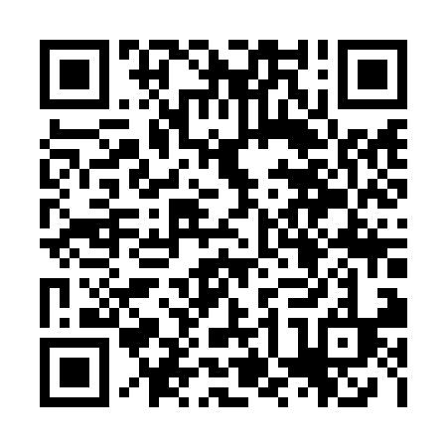
Prayer times for Milingimbi Island, Australia
Wed 1 May 2024 - Fri 31 May 2024
High Latitude Method: None
Prayer Calculation Method: Muslim World League
Asar Calculation Method: Shafi

Date | Day | Fajr | Sunrise | Dhuhr | Asr | Maghrib | Isha
1 | Wed | 5:25 | 6:37 | 12:28 | 3:48 | 6:18 | 7:26
2 | Thu | 5:25 | 6:37 | 12:27 | 3:48 | 6:17 | 7:26
3 | Fri | 5:25 | 6:38 | 12:27 | 3:47 | 6:17 | 7:25
4 | Sat | 5:25 | 6:38 | 12:27 | 3:47 | 6:17 | 7:25
5 | Sun | 5:25 | 6:38 | 12:27 | 3:47 | 6:16 | 7:25
6 | Mon | 5:25 | 6:38 | 12:27 | 3:47 | 6:16 | 7:24
7 | Tue | 5:25 | 6:38 | 12:27 | 3:47 | 6:16 | 7:24
8 | Wed | 5:26 | 6:39 | 12:27 | 3:47 | 6:15 | 7:24
9 | Thu | 5:26 | 6:39 | 12:27 | 3:47 | 6:15 | 7:24
10 | Fri | 5:26 | 6:39 | 12:27 | 3:46 | 6:15 | 7:24
11 | Sat | 5:26 | 6:39 | 12:27 | 3:46 | 6:14 | 7:24
12 | Sun | 5:26 | 6:39 | 12:27 | 3:46 | 6:14 | 7:23
13 | Mon | 5:26 | 6:40 | 12:27 | 3:46 | 6:14 | 7:23
14 | Tue | 5:26 | 6:40 | 12:27 | 3:46 | 6:14 | 7:23
15 | Wed | 5:26 | 6:40 | 12:27 | 3:46 | 6:14 | 7:23
16 | Thu | 5:27 | 6:40 | 12:27 | 3:46 | 6:13 | 7:23
17 | Fri | 5:27 | 6:41 | 12:27 | 3:46 | 6:13 | 7:23
18 | Sat | 5:27 | 6:41 | 12:27 | 3:46 | 6:13 | 7:23
19 | Sun | 5:27 | 6:41 | 12:27 | 3:46 | 6:13 | 7:23
20 | Mon | 5:27 | 6:41 | 12:27 | 3:45 | 6:13 | 7:23
21 | Tue | 5:27 | 6:42 | 12:27 | 3:45 | 6:13 | 7:23
22 | Wed | 5:27 | 6:42 | 12:27 | 3:45 | 6:12 | 7:23
23 | Thu | 5:28 | 6:42 | 12:27 | 3:45 | 6:12 | 7:23
24 | Fri | 5:28 | 6:42 | 12:27 | 3:45 | 6:12 | 7:23
25 | Sat | 5:28 | 6:43 | 12:27 | 3:45 | 6:12 | 7:23
26 | Sun | 5:28 | 6:43 | 12:28 | 3:45 | 6:12 | 7:23
27 | Mon | 5:28 | 6:43 | 12:28 | 3:45 | 6:12 | 7:23
28 | Tue | 5:29 | 6:43 | 12:28 | 3:45 | 6:12 | 7:23
29 | Wed | 5:29 | 6:44 | 12:28 | 3:45 | 6:12 | 7:23
30 | Thu | 5:29 | 6:44 | 12:28 | 3:46 | 6:12 | 7:23
31 | Fri | 5:29 | 6:44 | 12:28 | 3:46 | 6:12 | 7:23
Prayer times provided by https://www.salahtimes.com

