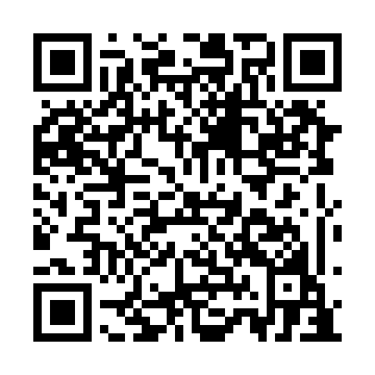
Prayer times for Batter Junction, Alberta, Canada
Wed 1 May 2024 - Fri 31 May 2024
High Latitude Method: Angle Based Rule
Prayer Calculation Method: Islamic Society of North America
Asar Calculation Method: Hanafi

Date | Day | Fajr | Sunrise | Dhuhr | Asr | Maghrib | Isha
1 | Wed | 4:00 | 5:57 | 1:24 | 6:32 | 8:52 | 10:50
2 | Thu | 3:57 | 5:55 | 1:24 | 6:33 | 8:54 | 10:53
3 | Fri | 3:54 | 5:54 | 1:24 | 6:34 | 8:55 | 10:56
4 | Sat | 3:51 | 5:52 | 1:24 | 6:35 | 8:57 | 10:59
5 | Sun | 3:48 | 5:50 | 1:24 | 6:36 | 8:59 | 11:01
6 | Mon | 3:45 | 5:48 | 1:24 | 6:37 | 9:00 | 11:04
7 | Tue | 3:42 | 5:47 | 1:24 | 6:38 | 9:02 | 11:07
8 | Wed | 3:39 | 5:45 | 1:24 | 6:39 | 9:03 | 11:10
9 | Thu | 3:36 | 5:43 | 1:24 | 6:40 | 9:05 | 11:13
10 | Fri | 3:33 | 5:42 | 1:24 | 6:41 | 9:07 | 11:15
11 | Sat | 3:32 | 5:40 | 1:24 | 6:42 | 9:08 | 11:16
12 | Sun | 3:31 | 5:38 | 1:24 | 6:43 | 9:10 | 11:17
13 | Mon | 3:30 | 5:37 | 1:24 | 6:44 | 9:11 | 11:18
14 | Tue | 3:30 | 5:35 | 1:24 | 6:44 | 9:13 | 11:18
15 | Wed | 3:29 | 5:34 | 1:24 | 6:45 | 9:14 | 11:19
16 | Thu | 3:28 | 5:32 | 1:24 | 6:46 | 9:16 | 11:20
17 | Fri | 3:28 | 5:31 | 1:24 | 6:47 | 9:17 | 11:21
18 | Sat | 3:27 | 5:30 | 1:24 | 6:48 | 9:19 | 11:21
19 | Sun | 3:26 | 5:28 | 1:24 | 6:49 | 9:20 | 11:22
20 | Mon | 3:26 | 5:27 | 1:24 | 6:50 | 9:22 | 11:23
21 | Tue | 3:25 | 5:26 | 1:24 | 6:50 | 9:23 | 11:24
22 | Wed | 3:24 | 5:24 | 1:24 | 6:51 | 9:24 | 11:24
23 | Thu | 3:24 | 5:23 | 1:24 | 6:52 | 9:26 | 11:25
24 | Fri | 3:23 | 5:22 | 1:24 | 6:53 | 9:27 | 11:26
25 | Sat | 3:23 | 5:21 | 1:24 | 6:54 | 9:28 | 11:26
26 | Sun | 3:22 | 5:20 | 1:24 | 6:54 | 9:30 | 11:27
27 | Mon | 3:22 | 5:19 | 1:25 | 6:55 | 9:31 | 11:28
28 | Tue | 3:21 | 5:18 | 1:25 | 6:56 | 9:32 | 11:28
29 | Wed | 3:21 | 5:17 | 1:25 | 6:56 | 9:33 | 11:29
30 | Thu | 3:21 | 5:16 | 1:25 | 6:57 | 9:34 | 11:30
31 | Fri | 3:20 | 5:15 | 1:25 | 6:58 | 9:35 | 11:30
Prayer times provided by https://www.salahtimes.com

