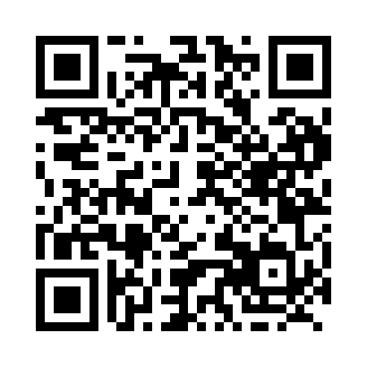
Prayer times for Boilleau, Quebec, Canada
Wed 1 May 2024 - Fri 31 May 2024
High Latitude Method: Angle Based Rule
Prayer Calculation Method: Islamic Society of North America
Asar Calculation Method: Hanafi

Date | Day | Fajr | Sunrise | Dhuhr | Asr | Maghrib | Isha
1 | Wed | 3:41 | 5:24 | 12:40 | 5:44 | 7:57 | 9:41
2 | Thu | 3:38 | 5:22 | 12:40 | 5:45 | 7:59 | 9:43
3 | Fri | 3:36 | 5:21 | 12:40 | 5:46 | 8:00 | 9:45
4 | Sat | 3:34 | 5:19 | 12:40 | 5:47 | 8:02 | 9:48
5 | Sun | 3:31 | 5:18 | 12:40 | 5:47 | 8:03 | 9:50
6 | Mon | 3:29 | 5:16 | 12:40 | 5:48 | 8:04 | 9:52
7 | Tue | 3:27 | 5:15 | 12:40 | 5:49 | 8:06 | 9:54
8 | Wed | 3:25 | 5:13 | 12:40 | 5:50 | 8:07 | 9:56
9 | Thu | 3:22 | 5:12 | 12:40 | 5:51 | 8:09 | 9:58
10 | Fri | 3:20 | 5:10 | 12:40 | 5:52 | 8:10 | 10:00
11 | Sat | 3:18 | 5:09 | 12:40 | 5:52 | 8:11 | 10:03
12 | Sun | 3:16 | 5:07 | 12:40 | 5:53 | 8:13 | 10:05
13 | Mon | 3:14 | 5:06 | 12:40 | 5:54 | 8:14 | 10:07
14 | Tue | 3:12 | 5:05 | 12:40 | 5:55 | 8:15 | 10:09
15 | Wed | 3:09 | 5:03 | 12:40 | 5:55 | 8:16 | 10:11
16 | Thu | 3:07 | 5:02 | 12:40 | 5:56 | 8:18 | 10:13
17 | Fri | 3:05 | 5:01 | 12:40 | 5:57 | 8:19 | 10:15
18 | Sat | 3:03 | 5:00 | 12:40 | 5:58 | 8:20 | 10:17
19 | Sun | 3:01 | 4:59 | 12:40 | 5:58 | 8:22 | 10:20
20 | Mon | 2:59 | 4:58 | 12:40 | 5:59 | 8:23 | 10:22
21 | Tue | 2:57 | 4:57 | 12:40 | 6:00 | 8:24 | 10:24
22 | Wed | 2:55 | 4:56 | 12:40 | 6:01 | 8:25 | 10:26
23 | Thu | 2:53 | 4:55 | 12:40 | 6:01 | 8:26 | 10:28
24 | Fri | 2:52 | 4:54 | 12:40 | 6:02 | 8:27 | 10:30
25 | Sat | 2:50 | 4:53 | 12:40 | 6:03 | 8:29 | 10:32
26 | Sun | 2:48 | 4:52 | 12:40 | 6:03 | 8:30 | 10:34
27 | Mon | 2:46 | 4:51 | 12:41 | 6:04 | 8:31 | 10:36
28 | Tue | 2:45 | 4:50 | 12:41 | 6:05 | 8:32 | 10:36
29 | Wed | 2:45 | 4:49 | 12:41 | 6:05 | 8:33 | 10:37
30 | Thu | 2:45 | 4:49 | 12:41 | 6:06 | 8:34 | 10:37
31 | Fri | 2:45 | 4:48 | 12:41 | 6:06 | 8:35 | 10:38
Prayer times provided by https://www.salahtimes.com

