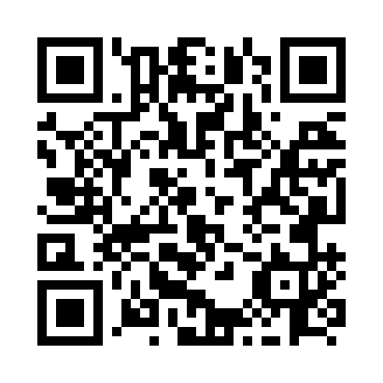
Prayer times for Ellerslie, Prince Edward Island, Canada
Mon 1 Jul 2024 - Wed 31 Jul 2024
High Latitude Method: Angle Based Rule
Prayer Calculation Method: Islamic Society of North America
Asar Calculation Method: Hanafi

Date | Day | Fajr | Sunrise | Dhuhr | Asr | Maghrib | Isha
1 | Mon | 3:23 | 5:27 | 1:20 | 6:45 | 9:13 | 11:16
2 | Tue | 3:24 | 5:27 | 1:20 | 6:45 | 9:12 | 11:16
3 | Wed | 3:25 | 5:28 | 1:20 | 6:45 | 9:12 | 11:15
4 | Thu | 3:26 | 5:29 | 1:20 | 6:45 | 9:12 | 11:14
5 | Fri | 3:27 | 5:29 | 1:21 | 6:45 | 9:11 | 11:13
6 | Sat | 3:28 | 5:30 | 1:21 | 6:45 | 9:11 | 11:12
7 | Sun | 3:30 | 5:31 | 1:21 | 6:44 | 9:10 | 11:11
8 | Mon | 3:31 | 5:32 | 1:21 | 6:44 | 9:10 | 11:10
9 | Tue | 3:32 | 5:33 | 1:21 | 6:44 | 9:09 | 11:09
10 | Wed | 3:34 | 5:33 | 1:21 | 6:44 | 9:09 | 11:08
11 | Thu | 3:35 | 5:34 | 1:21 | 6:43 | 9:08 | 11:07
12 | Fri | 3:37 | 5:35 | 1:22 | 6:43 | 9:07 | 11:05
13 | Sat | 3:39 | 5:36 | 1:22 | 6:43 | 9:07 | 11:04
14 | Sun | 3:40 | 5:37 | 1:22 | 6:42 | 9:06 | 11:03
15 | Mon | 3:42 | 5:38 | 1:22 | 6:42 | 9:05 | 11:01
16 | Tue | 3:43 | 5:39 | 1:22 | 6:42 | 9:04 | 11:00
17 | Wed | 3:45 | 5:40 | 1:22 | 6:41 | 9:03 | 10:58
18 | Thu | 3:47 | 5:41 | 1:22 | 6:41 | 9:03 | 10:56
19 | Fri | 3:49 | 5:42 | 1:22 | 6:40 | 9:02 | 10:55
20 | Sat | 3:50 | 5:43 | 1:22 | 6:40 | 9:01 | 10:53
21 | Sun | 3:52 | 5:44 | 1:22 | 6:39 | 9:00 | 10:51
22 | Mon | 3:54 | 5:45 | 1:22 | 6:39 | 8:59 | 10:50
23 | Tue | 3:56 | 5:47 | 1:22 | 6:38 | 8:58 | 10:48
24 | Wed | 3:58 | 5:48 | 1:22 | 6:37 | 8:56 | 10:46
25 | Thu | 3:59 | 5:49 | 1:22 | 6:37 | 8:55 | 10:44
26 | Fri | 4:01 | 5:50 | 1:22 | 6:36 | 8:54 | 10:42
27 | Sat | 4:03 | 5:51 | 1:22 | 6:35 | 8:53 | 10:40
28 | Sun | 4:05 | 5:52 | 1:22 | 6:35 | 8:52 | 10:39
29 | Mon | 4:07 | 5:54 | 1:22 | 6:34 | 8:50 | 10:37
30 | Tue | 4:09 | 5:55 | 1:22 | 6:33 | 8:49 | 10:35
31 | Wed | 4:11 | 5:56 | 1:22 | 6:32 | 8:48 | 10:33
Prayer times provided by https://www.salahtimes.com

