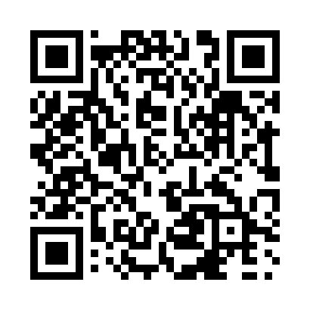
Prayer times for Des Ormeaux, Quebec, Canada
Mon 1 Jul 2024 - Wed 31 Jul 2024
High Latitude Method: Angle Based Rule
Prayer Calculation Method: Islamic Society of North America
Asar Calculation Method: Hanafi

Date | Day | Fajr | Sunrise | Dhuhr | Asr | Maghrib | Isha
1 | Mon | 3:00 | 5:02 | 12:54 | 6:19 | 8:46 | 10:48
2 | Tue | 3:01 | 5:03 | 12:54 | 6:19 | 8:45 | 10:47
3 | Wed | 3:02 | 5:03 | 12:54 | 6:19 | 8:45 | 10:47
4 | Thu | 3:03 | 5:04 | 12:55 | 6:19 | 8:45 | 10:46
5 | Fri | 3:04 | 5:05 | 12:55 | 6:18 | 8:44 | 10:45
6 | Sat | 3:05 | 5:06 | 12:55 | 6:18 | 8:44 | 10:44
7 | Sun | 3:07 | 5:06 | 12:55 | 6:18 | 8:44 | 10:43
8 | Mon | 3:08 | 5:07 | 12:55 | 6:18 | 8:43 | 10:42
9 | Tue | 3:09 | 5:08 | 12:55 | 6:18 | 8:42 | 10:41
10 | Wed | 3:11 | 5:09 | 12:56 | 6:17 | 8:42 | 10:40
11 | Thu | 3:12 | 5:10 | 12:56 | 6:17 | 8:41 | 10:38
12 | Fri | 3:14 | 5:11 | 12:56 | 6:17 | 8:41 | 10:37
13 | Sat | 3:15 | 5:12 | 12:56 | 6:17 | 8:40 | 10:36
14 | Sun | 3:17 | 5:12 | 12:56 | 6:16 | 8:39 | 10:34
15 | Mon | 3:18 | 5:13 | 12:56 | 6:16 | 8:38 | 10:33
16 | Tue | 3:20 | 5:14 | 12:56 | 6:15 | 8:38 | 10:32
17 | Wed | 3:22 | 5:15 | 12:56 | 6:15 | 8:37 | 10:30
18 | Thu | 3:23 | 5:16 | 12:56 | 6:15 | 8:36 | 10:28
19 | Fri | 3:25 | 5:17 | 12:56 | 6:14 | 8:35 | 10:27
20 | Sat | 3:27 | 5:19 | 12:56 | 6:14 | 8:34 | 10:25
21 | Sun | 3:29 | 5:20 | 12:57 | 6:13 | 8:33 | 10:24
22 | Mon | 3:30 | 5:21 | 12:57 | 6:12 | 8:32 | 10:22
23 | Tue | 3:32 | 5:22 | 12:57 | 6:12 | 8:31 | 10:20
24 | Wed | 3:34 | 5:23 | 12:57 | 6:11 | 8:30 | 10:18
25 | Thu | 3:36 | 5:24 | 12:57 | 6:11 | 8:29 | 10:17
26 | Fri | 3:38 | 5:25 | 12:57 | 6:10 | 8:27 | 10:15
27 | Sat | 3:39 | 5:26 | 12:57 | 6:09 | 8:26 | 10:13
28 | Sun | 3:41 | 5:27 | 12:57 | 6:08 | 8:25 | 10:11
29 | Mon | 3:43 | 5:29 | 12:57 | 6:08 | 8:24 | 10:09
30 | Tue | 3:45 | 5:30 | 12:56 | 6:07 | 8:23 | 10:07
31 | Wed | 3:47 | 5:31 | 12:56 | 6:06 | 8:21 | 10:05
Prayer times provided by https://www.salahtimes.com

