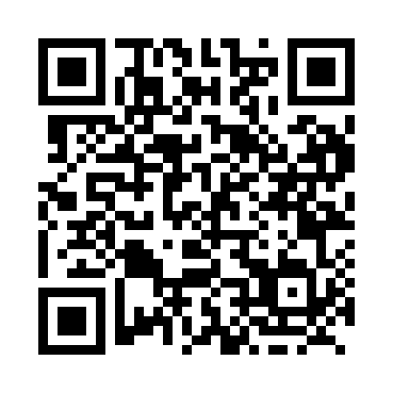
Prayer times for Taku, British Columbia, Canada
Mon 1 Jul 2024 - Wed 31 Jul 2024
High Latitude Method: Angle Based Rule
Prayer Calculation Method: Islamic Society of North America
Asar Calculation Method: Hanafi

Date | Day | Fajr | Sunrise | Dhuhr | Asr | Maghrib | Isha
1 | Mon | 3:21 | 4:43 | 1:59 | 7:57 | 11:16 | 12:38
2 | Tue | 3:22 | 4:44 | 2:00 | 7:57 | 11:15 | 12:37
3 | Wed | 3:22 | 4:45 | 2:00 | 7:56 | 11:14 | 12:37
4 | Thu | 3:23 | 4:46 | 2:00 | 7:56 | 11:13 | 12:36
5 | Fri | 3:24 | 4:48 | 2:00 | 7:56 | 11:12 | 12:36
6 | Sat | 3:24 | 4:49 | 2:00 | 7:55 | 11:11 | 12:36
7 | Sun | 3:25 | 4:50 | 2:00 | 7:55 | 11:10 | 12:35
8 | Mon | 3:26 | 4:52 | 2:01 | 7:54 | 11:09 | 12:34
9 | Tue | 3:27 | 4:54 | 2:01 | 7:54 | 11:07 | 12:34
10 | Wed | 3:28 | 4:55 | 2:01 | 7:53 | 11:06 | 12:33
11 | Thu | 3:29 | 4:57 | 2:01 | 7:53 | 11:04 | 12:33
12 | Fri | 3:30 | 4:59 | 2:01 | 7:52 | 11:03 | 12:32
13 | Sat | 3:31 | 5:00 | 2:01 | 7:51 | 11:01 | 12:31
14 | Sun | 3:32 | 5:02 | 2:01 | 7:51 | 11:00 | 12:30
15 | Mon | 3:33 | 5:04 | 2:01 | 7:50 | 10:58 | 12:29
16 | Tue | 3:34 | 5:06 | 2:02 | 7:49 | 10:56 | 12:29
17 | Wed | 3:35 | 5:08 | 2:02 | 7:48 | 10:54 | 12:28
18 | Thu | 3:36 | 5:10 | 2:02 | 7:47 | 10:52 | 12:27
19 | Fri | 3:37 | 5:12 | 2:02 | 7:47 | 10:51 | 12:26
20 | Sat | 3:38 | 5:14 | 2:02 | 7:46 | 10:49 | 12:25
21 | Sun | 3:39 | 5:16 | 2:02 | 7:45 | 10:47 | 12:24
22 | Mon | 3:40 | 5:18 | 2:02 | 7:44 | 10:44 | 12:23
23 | Tue | 3:41 | 5:20 | 2:02 | 7:43 | 10:42 | 12:22
24 | Wed | 3:42 | 5:23 | 2:02 | 7:41 | 10:40 | 12:21
25 | Thu | 3:43 | 5:25 | 2:02 | 7:40 | 10:38 | 12:20
26 | Fri | 3:44 | 5:27 | 2:02 | 7:39 | 10:36 | 12:19
27 | Sat | 3:45 | 5:29 | 2:02 | 7:38 | 10:33 | 12:17
28 | Sun | 3:46 | 5:31 | 2:02 | 7:37 | 10:31 | 12:16
29 | Mon | 3:48 | 5:34 | 2:02 | 7:35 | 10:29 | 12:15
30 | Tue | 3:49 | 5:36 | 2:02 | 7:34 | 10:26 | 12:14
31 | Wed | 3:50 | 5:38 | 2:02 | 7:33 | 10:24 | 12:13
Prayer times provided by https://www.salahtimes.com

