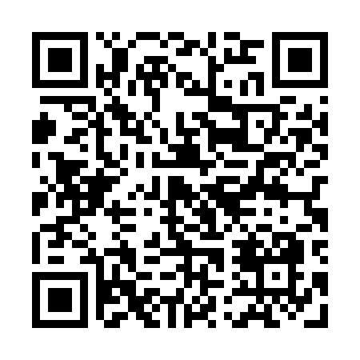
Prayer times for Black Cat Island, New Hampshire, USA
Sat 1 Jun 2024 - Sun 30 Jun 2024
High Latitude Method: Angle Based Rule
Prayer Calculation Method: Islamic Society of North America
Asar Calculation Method: Shafi

Date | Day | Fajr | Sunrise | Dhuhr | Asr | Maghrib | Isha
1 | Sat | 3:20 | 5:07 | 12:44 | 4:49 | 8:21 | 10:08
2 | Sun | 3:19 | 5:06 | 12:44 | 4:49 | 8:22 | 10:09
3 | Mon | 3:19 | 5:06 | 12:44 | 4:49 | 8:22 | 10:10
4 | Tue | 3:18 | 5:05 | 12:44 | 4:50 | 8:23 | 10:11
5 | Wed | 3:17 | 5:05 | 12:44 | 4:50 | 8:24 | 10:12
6 | Thu | 3:17 | 5:05 | 12:45 | 4:50 | 8:25 | 10:13
7 | Fri | 3:16 | 5:04 | 12:45 | 4:51 | 8:25 | 10:14
8 | Sat | 3:15 | 5:04 | 12:45 | 4:51 | 8:26 | 10:15
9 | Sun | 3:15 | 5:04 | 12:45 | 4:51 | 8:26 | 10:16
10 | Mon | 3:14 | 5:04 | 12:45 | 4:51 | 8:27 | 10:17
11 | Tue | 3:14 | 5:04 | 12:46 | 4:52 | 8:28 | 10:17
12 | Wed | 3:14 | 5:04 | 12:46 | 4:52 | 8:28 | 10:18
13 | Thu | 3:13 | 5:03 | 12:46 | 4:52 | 8:29 | 10:19
14 | Fri | 3:13 | 5:03 | 12:46 | 4:53 | 8:29 | 10:19
15 | Sat | 3:13 | 5:03 | 12:46 | 4:53 | 8:29 | 10:20
16 | Sun | 3:13 | 5:03 | 12:47 | 4:53 | 8:30 | 10:20
17 | Mon | 3:13 | 5:04 | 12:47 | 4:53 | 8:30 | 10:21
18 | Tue | 3:13 | 5:04 | 12:47 | 4:54 | 8:30 | 10:21
19 | Wed | 3:13 | 5:04 | 12:47 | 4:54 | 8:31 | 10:21
20 | Thu | 3:13 | 5:04 | 12:47 | 4:54 | 8:31 | 10:22
21 | Fri | 3:14 | 5:04 | 12:48 | 4:54 | 8:31 | 10:22
22 | Sat | 3:14 | 5:04 | 12:48 | 4:54 | 8:31 | 10:22
23 | Sun | 3:14 | 5:05 | 12:48 | 4:55 | 8:31 | 10:22
24 | Mon | 3:15 | 5:05 | 12:48 | 4:55 | 8:31 | 10:22
25 | Tue | 3:15 | 5:05 | 12:49 | 4:55 | 8:31 | 10:22
26 | Wed | 3:15 | 5:06 | 12:49 | 4:55 | 8:32 | 10:22
27 | Thu | 3:16 | 5:06 | 12:49 | 4:55 | 8:31 | 10:22
28 | Fri | 3:17 | 5:07 | 12:49 | 4:55 | 8:31 | 10:21
29 | Sat | 3:17 | 5:07 | 12:49 | 4:56 | 8:31 | 10:21
30 | Sun | 3:18 | 5:08 | 12:50 | 4:56 | 8:31 | 10:21
Prayer times provided by https://www.salahtimes.com

